WORKING DRAFT

31 January 2016

INTERNATIONAL HYDROGRAPHIC ORGANIZATION



BATHYMETRIC SURFACE PRODUCT SPECIFICATION

Edition 2.0.0 – DRAFT

IHO Publication S-102

Published by the

International Hydrographic Bureau

MONACO

Version Number | Date | Author | Purpose
1.0.0 | April 2012 | TSMAD | Approved edition of S-102
2.0.0

Contents Page
1 Overview 5
1.1 Introduction 5
1.2 References 5
1.3 Terms, definitions and abbreviations 6
1.3.1 Use of Language 6
1.3.2 Terms and Definitions 6
1.3.3 Abbreviations 10
1.4 General Data Product Description 11
1.5 Data product specification metadata 12
1.5.1 IHO Product Specification Maintenance 13
2 Specification Scopes 14
3 Dataset Identification 14
4 Data Content and structure 16
4.1 Introduction 16
4.2 Application Schema 17
4.2.1 Application Schema Implementation Classes 20
4.2.2 Tiling Scheme (Partitioning) 29
4.3 Feature Catalogue 33
4.3.1 Introduction 33
4.3.2 Feature Types 33
4.3.3 Feature Relationship 33
4.3.4 Attributes 33
4.4 S-102 Coverages 34
4.5 Tracking List 35
4.6 Surface Corrections 35
4.7 Extensions 35
4.8 Dataset Types 35
4.8.1 Data Coverage rules 35
4.9 Dataset Loading and Unloading 36
4.9.1 Dataset Loading and Unloading Algorithm 36
5 Coordinate Reference Systems (CRS) 40
5.1 Introduction 40
5.1.1 Spatial reference system: 40
5.1.2 Horizontal Coordinate Reference System 41
6 Data Quality 41
7 Data Capture and Classification 41
8 Maintenance 41
9 Portrayal 42
10 Data Product format (encoding) 42
10.1 Introduction 42
11 Data Product Delivery 42
11.1 Introduction 42
11.2 Dataset 43
11.2.1 Datasets 43
11.2.2 Dataset file naming 44
11.3 Exchange Catalogue 44
12 Metadata 44
12.1 Introduction 44
12.2 Discovery Metadata 46
12.3 Structure Metadata 49
12.3.1 Quality Metadata 53
12.3.2 Acquisition Metadata 56
12.4 Exchange Set Metadata 56
12.5 S102_ExchangeCatalogue 61
12.6 S102_CatalogueIdentifier 62
12.7 S102_CataloguePointofContact 63
12.8 S102_DatasetDiscoveryMetaData 63
12.9 S102_VerticalAndSoundingDatum 67
12.10 S102_DataFormat 69
12.11 S102_ProductSpecification 69
12.12 S102_SupportFileDiscoveryMetadata 70
12.13 S102_SupportFileFormat 72
12.14 S102_SupportFilePurpose 72
12.15 S102_Catalogue 73
12.16 Language 73
Annex A - Data Classification and Encoding Guide 75
A.1 Application Program Interface 80
A.1.1 Application Program General 80
A.1.2 Structure of the Source Tree 80
A.1.3 Basic Data Access 81
Annex B –Hierarchical Data Format Encoding 85
Annex C – Normative Implementation Guidance 86
Annex D – Feature Catalogue 86
Annex E – Portrayal Catalogue 86

Overview
Concurrent with the advent of electronic navigation, the need for high resolution bathymetric data in the form of a bathymetric model, has become a requirement to better enable the systematic fusion of temporal data such as tidal heights and also to enable the same data to be used for other applications where a shoal-biased model may not be optimal. Furthermore, having such a model allows an ECDIS or ECS to make other intelligent adjustments such as contour intervals.

The Bathymetric Surface data product described here incorporates the Navigation Surface concept. This means that, in addition to an estimation of depth and an estimate of the uncertainty associated with the depth, there is an ability to over-ride any automatically constructed depth estimates with ‘Hydrographer Privilege‘. Essentially, this is a means to specify directly the depth judged by a human observer as being the most significant in the area - irrespective of any statistical evidence to the contrary. The original grid values that are replaced by the hydrographer are preserved in the tracking list so that they can be restored if desired based on application.

Introduction
This document describes an S-100 compliant product specification for a Bathymetric Surface Product.

Much of this document has been adapted from the Format Specification Document – Description of the Bathymetric Attributed Grid Object (BAG) Version 1.0.0 [2]. Compliance with the S-102 product specification implies logical compliance with the BAG as specified by the Open Navigation Surface Project.

Bathymetric Surface data may be used alone or it may be combined with ENC or other S-100 compatible data. As such this Bathymetric Surface product specification describes one of a number of additional layers that could be integrated with other S-100 products for use with ENC.

The Bathymetric Surface Data Product specification defines a content model and an exchange file format for the exchange of bathymetric coverage data. The coverage type is a quadrilateral grid coverage together with attributes. The bathymetric coverage consist of mandatory, collocated coverges of elevation and uncertainty. Other optional coverage may be contined as well.

The encoding specified in this Product specification is based on HDF5, but as content and encoding are separated, it does not preclude transformation to other encodings such as GeoTIFF and XML.

References
S-100 IHO Universal Hydrographic Data Model
IHO S.100 IHO Universal Hydrographic Data Model, January 2010

IHO S.44 Standards for Hydrographic Surveys 5th Edition, February 2008

ISO 8601:2004 Data elements and interchange formats _ Information interchange _ Representation of dates and times

ISO/TS 19103:2005 Geographic information - Conceptual schema language

ISO 19111:2003 Geographic information - Spatial referencing by coordinates

ISO 19115:2003 Geographic information – Metadata

ISO 19115-2:2009 Geographic information - Metadata: Extensions for imagery and gridded data

ISO 19123:2005 Geographic information - Schema for coverage geometry and functions

ISO 19129:2009 Geographic information - Imagery gridded and coverage data framework

ISO 19131:2007 Geographic information - Data product specifications

ISO/IEC 19501:2005, Information technology — Open Distributed Processing - Unified Modelling
Language Version 1.4.2

Note: a summary of UML is given in S.100 Part 1

Format Specification Document - Description of Bathymetric Attributed Grid Object (BAG) - Version 1.0.0

Terms, definitions and abbreviations

Use of Language
Within this document:
- “Must” indicates a mandatory requirement.
- “Should” indicates an optional requirement, that is the recommended process to be followed, but is not mandatory.
- “May” means “allowed to” or “could possibly”, and is not mandatory.

Terms and Definitions

Coordinate
one of a sequence of numbers designating the position of a point in N-dimensional space
[ISO 19111]

coordinate reference system
coordinate system which is related to the real world by a datum
[ISO 19123]

coverage
feature that acts as a function to return values from its range for any direct position within its spatial, temporal, or spatiotemporal domain
[ISO1912]

EXAMPLE Examples include a digital image, polygon overlay, or digital elevation matrix.

NOTE In other words, a coverage is a feature that has multiple values for each attribute type, where each direct position within the geometric representation of the feature has a single value for each attribute type.

coverage geometry
configuration of the domain of a coverage described in terms of coordinates
[ISO 19123]

direct position
position described by a single set of coordinates within a coordinate reference system
[ISO 19107]

domain
well-defined set
[ISO 19103]

NOTE Domains are used to define the domain set and range set of operators and functions.

elevation
the altitude of the ground level of an object, measured from a specified vertical datum. [IHO:S100 GFM]

feature
abstraction of real world phenomena
[ISO 19101]

NOTE A feature may occur as a type or an instance. Feature type or feature instance should be used when only one is meant.

feature attribute
characteristic of a feature
[ISO 19109]

NOTE A feature attribute type has a name, a data type and a domain associated to it. A feature attribute instance has an attribute value taken from the value domain of the feature attribute type.

function
rule that associates each element from a domain (source, or domain of the function) to a unique element in another domain (target, co-domain, or range)
[ISO 19107]

NOTE The range is defined by another domain.

geometric object
spatial object representing a set of direct positions
[ISO 19107]

NOTE A geometric object consists of a geometric primitive, a collection of geometric primitives, or a geometric complex treated as a single entity. A geometric object may be the spatial characteristics of an object such as a feature or a significant part of a feature

grid
network composed of two or more sets of curves in which the members of each set intersect the members of the other sets in a systematic way
[ISO 19123]

NOTE The curves partition a space into grid cells.

grid point
point located at the intersection of two or more curves in a grid
[ISO 19123]

height
distance of a point from a chosen reference surface measured upward along a line perpendicular to that surface
[ISO 19111:2006]

NOTE Height is distinguished from elevation in that it is a directional measurement.

LIDAR
an optical remote sensing technique that uses a laser pulse to determine distance

NOTE LIDAR may be used to determine depth in shallow water areas.

navigation surface
A BAG data object representing the bathymetry and associated uncertainty with the methods by which those objects can be manipulated, combined and used for a number of tasks, certified for safety of navigation
[ONS FSD]

range
<coverage>
set of values associated by a function with the elements of the spatiotemporal domain of a
coverage
[ISO 19123]

record
finite, named collection of related items (objects or values) [ISO 19107]

NOTE Logically, a record is a set of pairs <name, item >.

rectified grid
grid for which there is a linear relationship between the grid coordinates and the coordinates of an external coordinate reference system
[ISO 19123]

NOTE If the coordinate reference system is related to the earth by a datum, the grid is a georectified grid.

referenceable grid
grid associated with a transformation that can be used to convert grid coordinate values to values of
coordinates referenced to an external coordinate reference system
[ISO 19123]

SONAR
a technique that uses sound propagation through water to determine distance, primarily depth
measurement

spatiotemporal domain
<coverage>
domain composed of geometric objects described in terms of spatial and/or temporal coordinates
[ISO 19123]

NOTE The spatiotemporal domain of a continuous coverage consists of a set of direct positions defined in relation to a collection of geometric objects.

surface
connected 2-dimensional geometric primitive, representing the continuous image of a region of a plane
[ISO 19107]

NOTE The boundary of a surface is the set of oriented, closed curves that delineate the limits of the surface.

tiling scheme
a discrete grid coverage that is used to partition data into discrete edge matched sets called tiles

uncertainty
The interval (about a given value) that will contain the true value of the measurement at a specific confidence level
[IHO S44]

NOTE Errors exist and are the differences between the measured value and the true value. Since the true value is never known it follows that the error itself cannot be known. Uncertainty is a statistical assessment of the likely magnitude of this error.

vector
quantity having direction as well as magnitude
[ISO 19123]

NOTE A directed line segment represents a vector if the length and direction of the line segment are equal to the magnitude and direction of the vector. The term vector data refers to data that represents the spatial configuration of features as a set of directed line segments.

Abbreviations
This product specification adopts the following convention for presentation purposes:
API Application Programming Interface
BAG Bathymetric Attributed Grid

DS Digital Signature

DSS Digital Signature Scheme

ECDIS Electronic Chart Display Information System

ECS Electronic Chart System

ENC Electronic Navigational Chart

GML Geography Markup Language

IHO International Hydrographic Organization

ISO International Standards Organization

LIDAR Light Detection And Ranging

NS Navigation Surface

ONS Open Navigation Surface

PK Public Key

SA Signature Authority

SK Secret Key

SONAR Sound Navigation And Ranging

UML Universal Modelling Language

General Data Product Description
Title: S-102 - Bathymetric Surface Product Specification.

Abstract: This document is a product specification for bathymetric surface data which may be used alone or as an auxiliary layer of data with an ENC. It specifies a navigation surface coverage including both depth and uncertainty together with an optional tracking list of the depth changes that have been manually replaced in the surface by the hydrographer to override the statistical grid value points to ensure safety of navigation. This product specification includes a content model and separate encodings.

Content: The Product Specification defines all requirements to which S-102 bathymetric data products must conform. Specifically it defines the data product content in terms of features and attributes within the feature catalogue. The display of features is defined by the symbols and rule sets contained in the portrayal catalogue. The Data Classification and Encoding Guide (DCEG) provides guidance on how data product content must be captured. (Annex A) In addition, Annex C will provide implementation guidance for developers.
Spatial Extent:
Description: Areas specific to marine navigation.
East Bounding Longitude: 180°
West Bounding Longitude: -180°
North Bounding Latitude: 90°
South Bounding Latitude: -90°

Purpose: A Bathymetric Surface Data Product contains the grid data values required to define a coverage data set representing the depth, and the associated uncertainty of that depth, of the sea or other navigable waterway together with associated metadata. The coverage data include an additional point set of values called "track changes" that provides an audit of hydrographer overrides to the original bathymetric surface to ensure the product supports safe navigation. It also provides for the inclusion of optional layers including a separation layer that provides the definition of the offsets between chart datum and mean sea level as well as the ellipsoidal surface. The data product may be use independently or as a part of a set of auxiliary data layers to be used with ENC data or other S-100 data products. The metadata data and structure required to support the aggregation of a set of auxiliary data layers are described in S-100 Part 8 Section 8.7.

A Bathymetric Surface Data Product may exist anywhere in the maritime domain. There are no limitations to its extent. A particular supplier, such as a national hydrographic office, may establish its own series of ENCs and auxiliary data that can be used together or with other S-100 data. These series may include Bathymetric Surface data. When used together with other data layers the requirement is that the reference system be the same or be directly convertible for all layers and that the tiling schemes align.

Data product specification metadata
This information uniquely identifies this Product Specification and provides information about its creation and maintenance. For further information on dataset metadata see clause 12.
Title: The International Hydrographic Organization Bathymetric Surface Product Specification
S-100 Version: 2.0.0
S-102 Version: 2.0.0
Date: TBD
Language: English
Classification: Unclassified
Contact: International Hydrographic Bureau (IHB)
4 Quai Antoine 1er
B.P. 445
MC 98011 MONACO CEDEX
Telephone: +377 93 10 81 00
Fax: + 377 93 10 81 40

URL: www.iho.int
Identifier: S-102
Maintenance: Changes to the Product Specification S-102 are coordinated by the S-100 working group of the IHO and must be made available via the IHO web site. Maintenance of the Product Specification must conform to IHO Technical Resolution 2/2007 (revised 2010).

IHO Product Specification Maintenance

Introduction
Changes to S-10n will be released by the IHO as a new edition, revision, or clarification.

New Edition
New Editions of S-102 introduce significant changes. New Editions enable new concepts, such as the ability to support new functions or applications, or the introduction of new constructs or data types. New Editions are likely to have a significant impact on either existing users or future users of S-102.

Revisions
Revisions are defined as substantive semantic changes to S-102. Typically, revisions will change S-102 to correct factual errors; introduce necessary changes that have become evident as a result of practical experience or changing circumstances. A revision must not be classified as a clarification. Revisions could have an impact on either existing users or future users of S-102. All cumulative clarifications must be included with the release of approved corrections revisions.

Changes in a revision are minor and ensure backward compatibility with the previous versions within the same Edition. Newer revisions, for example, introduce new features and attributes. Within the same Edition, a dataset of one version could always be processed with a later version of the feature and portrayal catalogues.

In most cases a new feature or portrayal catalogue will result in a revision of S-102.

Clarification
Clarifications are non-substantive changes to S-102. Typically, clarifications: remove ambiguity; correct grammatical and spelling errors; amend or update cross references; insert improved graphics in spelling, punctuation and grammar. A clarification must not cause any substantive semantic change to S-102.

Changes in a clarification are minor and ensure backward compatibility with the previous versions within the same Edition. Within the same Edition, a dataset of one clarification version could always be processed with a later version of the feature and portrayal catalogues, and a portrayal catalogue can always rely on earlier versions of the feature catalogues.

Version Numbers
The associated version control numbering to identify changes (n) to S-102 must be as follows:
New Editions denoted as n.0.0
Revisions denoted as n.n.0
Clarifications denoted as n.n.n

Specification Scopes
The Bathymetric Surface Data Product specification defines a content model and exchange file format for the exchange of bathymetric coverage data. The coverage type is a multi–layered quadrilateral grid coverage together with attributes.

A single S-102 coverage object represents one contiguous area of the skin of the Earth at a single resolution, but can represent data at any stage of the process from raw grid to final product. The term Navigation Surface (NS) is reserved for a final product for safety of navigation purposes.

An Application Programming Interface (API) exists which provides an abstraction from the underlying technologies as well as providing a set of methods for an application programmer to easily read and write data conforming to the this specification.

Each data supplier, such as a national hydrographic office, may establish its own series of bathymetric data products that may be used independently or in conjunction with other auxiliary data layers.

Scope ID: Global
Level: 006 - series
Level name: BAG

Dataset Identification
Title: S-102 Bathymetric Surface
Alternate Title: BAG – Bathymetric Attributed Grid
Abstract: The Bathymetric Surface Data Product consists of a set of grid value matrix values organized to form a quadrilateral grid coverage with associated metadata representing a bathymetric depth model for an area of the sea, river, lake or other navigable water. The data set includes both depth estimate values and uncertainty estimates associated with the depth values. In addition a discrete point set called a "tracking list" allows a hydrographer to override any particular grid matrix value to deliberately bias the data for safety of navigation. That is, the data set can carry both measured depth information that may be used for scientific purposes as well as corrected depth information that may be used for navigation.

Topic Category: Main topics for the product, as defined by the ISO 19115 MD_TopicCategoryCode:

006– elevation;

012– oceans;

014– inlandWaters

Geographic Description: Areas specific to marine navigation.
Spatial Resolution: The spatial resolution, or the spatial dimension on the earth covered by the size of a grid matrix cell (nominal ground sample distance), varies according to the model adopted by the producer (hydrographic office).

An S-102 dataset represents coverages. Each data set must carry a value for maximum display scale. Each data set must also carry a value for minimum display scale. Values must be taken from the following table:
Scale
NULL (only allowed on minimum display scale where the maximum display scale = 10,000,000)
1:10,000,000
1:3,500,000
1:1,500,000
1:700,000
1:350,000
1:180,000
1:90,000
1:45,000
1:22,000
1:12,000
1:8,000
1:4,000
1:3,000
1:2,000
1:1,000
Table 1- S-102 Minimum Display and Maximum Display Scales

Purpose: The primary purpose of the Bathymetric Surface Data Product is to support safe navigation as an auxiliary aid to navigation that may be used together with an ENC. The secondary use is as an independent source of depth information that may be used for other purposes.

Language: English (Mandatory), other (Optional)
Classification: Data may be classified as one of the following as defined by ISO 19115 MD_SecurityConstraints>MD_ClassificationCode (codelist)

Unclassified
Restricted
Confidential
Secret
Top Secret

Spatial Representation Type: Type of spatial representation for the product, as defined by the ISO 19115
MD_SpatialRepresentationTypeCode:

002 - grid.

Point of Contact: Producing Agency
Use Limitation: For SOLAS navigation an S-102 dataset must have a corresponding S-101 ENC dataset.

Data Content and structure

Introduction
The Navigation Surface concept used in the Bathymetric Surface Data Product requires that in addition to estimation of depth, an estimate of the uncertainty associated with the depth must be computed and preserved. In order to make the system suitable to support safety of navigation applications, there is a means to over-ride any automatically constructed depth estimates with ‘Hydrographer Privilege‘, (essentially , a means to specify directly the depth determined by a human observer as being the most significant in the area - irrespective of any statistical evidence to the contrary). The original grid values that are replaced by the hydrographer are preserved in the tracking list so that they can be restored if required.

Figure 1 shows a high level overview of the structure of S-102. It shows that the Bathymetric Surface Data Product consists of a set of data comprising the Bathymetric Attributed Grid (BAG). The BAG consists of a version tag plus other metadata, together with coverages consisting of elevation values and an uncertainty as two colocated coverages as well as the tracking list. S-102 used the IHO S-63 Data Protection Scheme to ensure certification and authentication.

Figure 1 - Overview Structure of S-102

Thus, the Bathymetric Surface Data Product is a hybrid of coverage(s), as defined in

IHO S-100 Part 8, and Information Types as defined in IHO S-100 Part 4, together with a point set tracking list. This is described in clause 4.2.

Application Schema
The Application Schema for S-102 is a template application schema. That is, it does not resolve all attributes and allows some choice. This means that an implementer, such as a national hydrographic office, can produce another application schema as a profile of this application schema that makes additional choices. For example, the choice of whether to use a tiling scheme and which tiling scheme to use is left open. An implementer, such as a national hydrographic office, can select the tiling scheme, extent, resolution and other parameters most appropriate for their situation. Since the general structure is defined by the template Application Schema, common software that supports the S-102 template schema is able to support national and other more specific profiles.

The Application Schema Data Set Structure is shown in Figures 2 and 3. They show a number of classes specialized for use in S-102 and two sets of implementation classes. An actual data set of S-102 bathymetry data only contains the implementation classes. All of the required attributes from the other classes in the application schema are satisfied by statements within the product specification. This approach to producing the application schema results in a very simple structure for implementation.

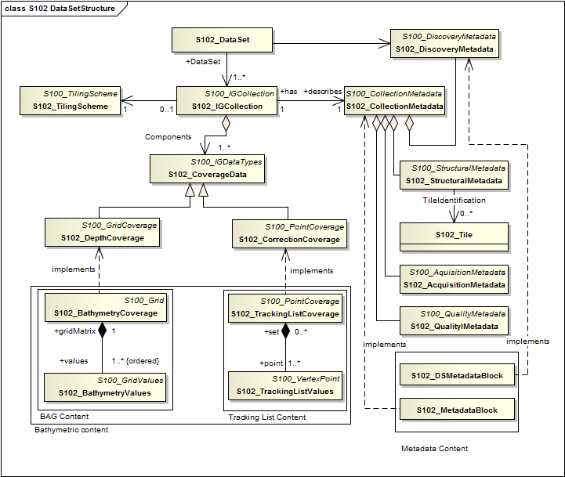
Figure 2 - Data Set Structure of S-102
The model in Figure 2 states that:

An S-102 data set (S102_DataSet), which is inherited from S100_DataSet, references an S-102 Image and Gridded Data Collection (S102_IGCollection). The relationship allows a 1 to many (1..*) multiplicity which means that there may be multiple instances of S-102 data collections. Each collection may or may not correspond to a tiling scheme, and each S-102 DataSet would correspond to a single tile. The S-102 discovery metadata class (S102_DiscoveryMetadata) describes the metadata entities required for the identification of the entire data set. The required discovery metadata is implemented through the S102_DSMetadataBlock class.

An instance of an S-102 Image and Gridded Data Collection (S102_IGCollection) which is a subtype of S100_ IGCollection, is described by a set of S-102 Collection Metadata (S102_CollectionMetadata). This relationship is 1 to 1 meaning that there is one set of collection metadata for each instance of S102_IGCollection. There is a large choice of metadata that may be used in a S-100 compliant data product. Only a small amount of this metadata is mandated by ISO 19115 for discovery. The choice of metadata is discussed in clause 12. Much of the metadata can be resolved as part of the product specification. Only that metadata that varies IG_collection item to item needs be included in the S102_MetadataBlock implementation class.

An S-102 Image and Gridded Data Collection also optionally makes reference to a tiling scheme.
This is discussed further in section 4.2.2.

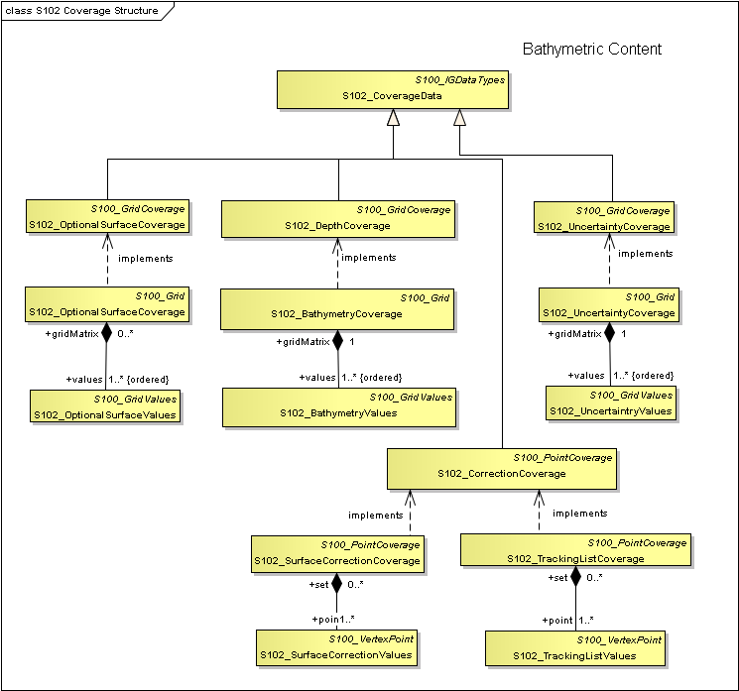
Figure 3 - Coverage Structure of S-102

The model in Figure 3 states that:

There are two coverage types in this application schema. The first is a set of discrete Quadrilateral Grid Coverages called S102_DepthCoverage, S102_UncertaintyCoverage and S102_OptionalSurfaceCoverage all of which it inherits from (S100_GridCoverage). Many of the parameters of the coverage are described in the product specification. These implementation classes are co-registered, co-geospatially located datasets.

The second coverage type is discrete point set coverage called S102_CorrectionCoverage and the S102_TrackingListCoverage. The S102_TrackingListCoverage consists of a set of discrete points that correspond to locations which had corrective overrides applied. (I.E. A hydrographer may explicitly specify depth values at specific points to deliberately ensure safety of navigation.) The S102_CorrectionCoverage is provided for pedigree. A coverage function to determine depth would operate on the resultant conflated continuous mathematical surface. The conflation function simply replaces specific values from the S102_BathymetryValues grid values matrix with the corresponding overriding values.

Application Schema Implementation Classes
The implementation classes for the template application schema are shown in Figure 4. The attributes are shown for the coverage related classes together with the attribute classes.

In order to simplify the implementation a number of defaults are assumed for S-102. These defaults make the implementation very simple, and ensures an instance of an S-102 Bathymetric Surface Product Specification in HDF5 encoding parallels the Navigation Surface implementation from the Open Navigation Surface Working Group. In the following sub clauses the default values are emphasised so that they do not need to be encoded when generating an encoding of the implementation classes. However, if specified they must assume the stated values unless other options are stated.

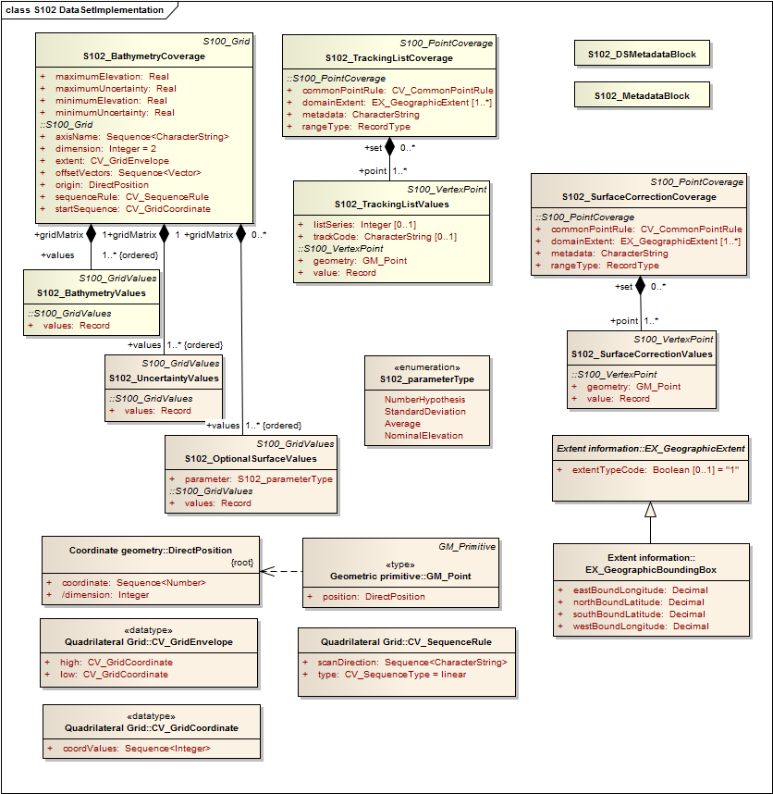
Figure 4 - Implementation of Classes of S-102

Implementation Classes Description

S102_BathymetryCoverage

S102_BathymetryCoverage semantics
The class S102_BathymetryCoverage has the attributes minimumElevation, maximumElevation, minimumUncertainity, and maximumUncertainty which bound the depthEstimate attribute and the uncertainity attribute from the S102_BathymetryValues record and S102_UncertaintyValues record and the inherited attributes origin, offsetVectors, dimension, axisName, extent, sequenceRule, and startSequence from S100_Grid and CV_Grid. The origin is a position in a specified coordinate reference system, and a set of offset vectors specify the direction and distance between the grid lines. It also contains the additional geometric characteristics of a rectified grid.

minimumElevation
The attribute minimumElevation has the value type Real and describes the lower bound of the depth estimate for all the depthEstimate values in S102_BathymetryValues record. This attribute is required. There is no default.

maximumElevation
The attribute maximumElevation has the value type Real and describes the upper bound of the depth estimate for all the depthEstimate values in S102_BathymetryValues record. This attribute is required. There is no default.

minimumUncertainty
The attribute minimumUncertainty has the value type Real and describes the lower bound of the uncertainty of the depth estimate for all the depthEstimate values in S102_BathymetryValues record. This attribute is required. There is no default.

maximumUncertainty
The attribute maximumUncertainty has the value type Real and describes the upper bound of the uncertainty of the depth estimate for all the depthEstimate values in S102_BathymetryValues record. This attribute is required. There is no default.

origin
The attribute origin has the value class DirectPosition which is a position that shall locate the origin of the rectified grid in the coordinate reference system. This attribute is required. There is no default.

offsetVectors
The attribute offsetVectors has the value class Sequence<Vector> that shall be a sequence of offset vector elements that determine the grid spacing in each direction. The data type Vector is specified in ISO/TS 19103. This attribute is required. There is no default.

dimension
The attribute dimension has the value class Integer that shall identify the dimensionality of the grid. The value of the grid dimension in this product specification is 2. This value is fixed in this product specification and does not need to be encoded.

axisName
The attribute axisName has the value class Sequence<CharacterString> that shall be used to assign names to the grid axis. The grid axis names shall be "Latitude" and "Longitude" for unprojected data sets or ―Northing‖ and ―Easting‖ in a projected space.

extent
The attribute extent has the value class CV_GridEnvelope that shall contain the extent of the spatial domain of the coverage. It uses the value class CV_GridEnvelope which provides the grid coordinate values for the diametrically opposed corners of the grid. The default is that this value is derived from the bounding box for the data set or tile in a multi tile data set.

sequenceRule
The attribute sequenceRule has the value class CV_SequenceRule that shall describe how the grid points are ordered for association to the elements of the sequence values. The default value is "Linear". No other options are allowed.

startSequence
The attribute startSequence has the value class CV_GridCoordinate that shall identify the grid point to be associated with the first record in the values sequence. The default value is the lower left corner of the grid. No other options are allowed.

S102_BathymetryValues

S102_BathymetryValues semantics
The class S102_BathymetryValues is related to S102_BathymetryCoverage by a composition relationship in which an ordered sequence of depthEstimate values provide data values for each grid cell. The class S102_BathymetryValues inherits from S100_Grid.

values
The attribute values has the values class Record which is a sequence of value items that shall assign values to the grid points. There is a single value in each record in the S102_BathymetryValues class which provides the depthEstimate for the grid cell. The definition for the depth type is defined by the depthCorrectionType attribute in the S102_BAGDataIdentification class.

S102_UncertaintyValues

S102_UncertaintyValues semantics
The class S102_UncertaintyValues is related to S102_BathymetryCoverage by a composition relationship in which an ordered sequence of uncertainty values provide data values for each grid cell.

values
The attribute values has the values class Record which is a sequence of value items that shall assign values to the grid point. There is a single value in each record in the S102_UncertaintyValues class which provides the uncertainty for the grid cell. The definition of the type of data in the values record is defined by the verticalUncertaintyType attribute in the S102_BAGDataIdentification class.

S102_OptionalSurfaceValues

S102_OptionalSurfaceValues semantics
The class S102_OptionalSurfaceValues is related to S102_BathymetryCoverage by a composition relationship in which an ordered sequence of optional values provide data values for each grid cell forming a surface for an optional parameter. The parameter type is specified in the attribute parameter. Note, there may be 0 or more S102_OptionalSurfaceValues per S102_BathymetryCoverage.

parameter
The attribute parameter identifies the type of data in the values record.

values

The attribute values has the values class Record which is a sequence of value items that shall assign values to the grid point. There is a single value in each record in the S102_OptionalSurfacesValues class which provides the parameter value for the grid cell. The definition of the type of data in the values record is defined by the parameter attribute.

DirectPosition

DirectPosition semantics

The class DirectPosition hold the coordinates for a position within some coordinate reference system.

coordinate

The attribute coordinate is a sequence of Numbers that hold the coordinate of this position in the specified reference system.

dimension
The attribute dimension is a derived attribute that describes the length of coordinate.

Vector

Vector semantics

The class Vector is an ordered set of numbers called coordinates that represent a position in a coordinate system.

dimension
The attribute dimension is a derived attribute that describes the length of the sequence of vector coordinates.

coordinates

The attribute coordinates is a sequence of Numbers that hold the coordinate of this position in the specified reference system.

CV_GridEnvelope

CV_GridEnvelope semantics
The class CV_GridEnvelope provides the grid coordinate values for the diametrically opposed corners of an envelope that bounds a grid. It has two attributes.

low
The attribute low shall be the minimal coordinate values for all grid points within the envelope. For this specification this represents the Southwestern coordinate.

high
The attribute high shall be the maximal coordinate values for all grid points within the envelope. For this specification this represents the Northeastern coordinate.

CV_GridCoordinate

CV_GridCoordinate semantics
The class CV_GridCoordinate is a data type for holding the grid coordinates of a CV_GridPoint.

coordValues
The attribute coordValues has the value class Sequence <Integer> that shall hold one integer value for each dimension of the grid. The ordering of these coordinate values shall be the same as that of the elements of axisNames. The value of a single coordinate shall be the number of offsets from the origin of the grid in the direction of a specific axis.

CV_SequenceRule

CV_SequenceRule semantics
The class CV_SequenceRule contains information for mapping grid coordinates to a position within the sequence of records of feature attribute values. It has two attributes.

type
The attribute type shall identify the type of sequencing method that shall be used. A code list of scan types is provided in S-100 Part 8. Only the value ―linear‖ shall be used in S-102, which describes scanning row by row by column.

scanDirection
The attribute scanDirection has the value class Sequence<CharacterString> a list of axis names that indicates the order in which grid points shall be mapped to position within the sequence of records of feature attribute values. The scan direction for all layers in S-102 is "Longitude" and "Latitude" or west to east, then south to north.

S102_TrackingListCoverage

S102_ TrackingListCoverage semantics
The class S102_TrackingListCoverage has the attributes domainExtent, rangeType, CommonPointRule and metadata inherited from S100_PointCoverage. The S102_TrackingList Coverage is a discrete point coverage which is used to track overriden nodes in the S102_BathymetryCoverage by allowing a hydrographer to apply a bias for safety of navigation. The attribute metadata provides one method of linking the metadata to the coverage inherited from S-100, however it is not required in S-102 because there is no need for specific metadata at the feature (class) level. The attribute commonPointRule is also not required because the value has been established for the whole of the S-102 data product to be "average". The attribute rangeType takes on the value class RecordType. This is modelled by the composition of multiple instances of S102_TrackingListValues. Therefore only the attribute domainExtent is required, and it has a default value.

domainExtent
The attribute domainExtent has the value class EX_GeographicExtent which describes the spatial boundaries of the tracking list elements within the bounds established by CV_GridEnvelope for the S102_BathymetryGrid. The default is the bounds established by the attribute CV_GridEnvelope.

S102_TrackingListValues

S102_TrackingListValues semantics
The class S102_TrackingListValues has the attributes trackCode and listSeries and the attributes geometry, and value inherited from S100_VertexPoint and CV_GeometryValuePair. The tracking list is a discrete coverage used to furnish the set of values that were overriden in the S102_BathymetryValues class. In order to assure alignment of tracking list values with the grid cells in the bathymetry coverage grid, the reference system for the tracking list is the bathymetry coverage quadrilateral grid.

The trackCode value and the listSeries value provide context for the override a value from the bathymetry coverage. The trackCode value is a text string that describes the reason for the override.

trackCode
The optional attribute trackCode has the value type CharacterString which may contain a text string describing the reason for the override of the corresponding depth and uncertainty values in the bathymetry coverage. This is a user definable field with values defined in the lineage metadata.

listSeries
The attribute listSeries has the value type Integer which contains an index number into a list of metadata elements describing the reason for the override of the corresponding depth and uncertainty values in the bathymetry coverage.

geometry
The attribute geometry has the value class GM_Point which is a position that shall locate the tracking list value. When the S102_TrackingListCoverage discrete coverage and the S102_BathymetryCoverage are conflated the values that are overridden in the sequence of the attribute S102-BathymetryValues are located by position. The value class is GM_Point which is the x, y grid post coordinate of the coverage.

value
The attribute value has the value class Record which is a sequence of value items that shall assign values to the discrete grid point. There are two values in each record in the S102_ TrackingListValues class. These are the depth and the uncertainty values that were overridden in corresponding grid coverages.

S102_SurfaceCorrectionCoverage

S102_SurfaceCorrectionCoverage semantics
The class S102_SurfaceCorrectionCoverage has the attributes domainExtent, rangeType, CommonPointRule and metadata inherited from S100_PointCoverage. The S102_SurfaceCorrectionCoverage is a discrete point coverage which is used to provide vertical offset of the nodes in the S102_BathymetryCoverage to mathematical or geopotential surfaces. The attribute metadata provides the definition of the values in each values record. The attribute domainExtent is required. The attribute commonPointRule is not required because the value has been established for the whole of the S-102 data product to be "average". The attribute rangeType takes on the value class RecordType. This is not required for S-102 because it defaults to a ―Simple List‖. No other value is allowed.

domainExtent
The attribute domainExtent has the value class EX_GeographicExtent which describes the spatial boundaries of the surface correction coverage within the bounds established by CV_GridEnvelope for the S102_BathymetryGrid. The default is the bounds established by the attribute CV_GridEnvelope.

parameter
The attribute parameter defines the optional layer of values in the S102_SurfaceCorrectionValues It is of type parameterType.

S102_SurfaceCorrectionValues

S102_SurfaceCorrectionValues semantics
The class S102_SurfaceCorrectionValues has the attributes geometry and value inherited from S100_VertexPoint and CV_GeometryValuePair. The correction surface is a discrete coverage used to furnish the set of values that can be used to perform a vertical shift of values in the S102_BathymetryValues class. These are point values that are used to construct a coarse surface used for referencing the bathymetric coverage to mean sea level, the ellipsoid or any other specified dataum.

geometry
The attribute geometry has the value class GM_Point which is a position that shall locate the surface corrector value. When the S102_SurfaceCorrectionCoverage discrete coverage and the S102_BathymetryCoverage are conflated the values provide offsets to shift the bathymetric values in the vertical. The value class is GM_Point which is a coordinate related to the reference system of the bathymetry coverage quadrilateral grid.

value
The attribute value has the value class Record which is a sequence of value items that shall assign values to the discrete grid point. These are defined in the metadata attribute in the S102_SurfaceCorrectionCoverage.

GM_Point semantics
The class GM_Point is taken from ISO 19107 and is the basic data type for a geometric object consisting of one and only one point. It has one attribute.

position
The attribute position is derived from DirectPosition for the geometry primitive GM_Point. In order to assure alignment of tracking list values with the grid points in the bathymetry coverage grid, the reference system for the tracking list is the bathymetry coverage quadrilateral grid. This means that the position attribute corresponds to a grid point. For a uniform quadrilateral grid this is the row and column of the grid point position.

EX_GeographicExtent

EX_GeographicExtent semantics
The class EX_GeographicExtent is a metadata class from ISO 19115. It is a component of the metaclass EX_Extent. The use of EX_Extent is optional. When used it describes the spatial boundaries of the Tracking List elements within the bounds established by CV_GridEnvelope for the S102_BathymetryGrid. That is, the tracking list may carry information corresponding only to a portion of the spatial extent covered by the S102_BathymetryGrid. There is one attribute and one subtype.

ExtentTypeCode
The attribute extentTypeCode is a Boolean value. It is used to indicate whether the bounding polygon/box encompasses an area covered by the data or an area where data is not present. In S-102 it is set to 1.

EX_BoundingBox

EX_GeographicBoundingBox semantics
The class EX_GeographicBoundingBox is a metadata class from ISO 19115. It is a subtype of the abstract class EX_GeographicExtent. It defines a bounding box used to indicate the spatial boundaries of the tracking list elements within the bounds established by CV_GridEnvelope for the S102_BathymetryGrid. It has four attributes.

westBoundLongitude
The attribute westBoundLongitude is a coordinate value providing the west bound longitude for the bound.

eastBoundLongitude
The attribute eastBoundLongitude is a coordinate value providing the east bound longitude for the bound.

southBoundLatitude
The attribute southBoundLatitude is a coordinate value providing the south bound longitude for the bound.

northBoundLatitude
The attribute northBoundLatitude is a coordinate value providing the north bound longitude for the bound

Tiling Scheme (Partitioning)
Tiling is a technique to decompose an area of interest into smaller more manageable chunks of data or partition. Each tile for an S-102 Bathymetry data product is a complete bathymetry grid with a depth and uncertainty coverage and optional tracking list together with metadata that is edge matched to adjacent tiles.

A Tiling scheme is a second higher level discrete grid coverage where the tiles are the value items of the discrete coverage. As such a tiling scheme requires a complete description as a coverage.

The tiling scheme does not have to be described with the data set, but it is necessary that the data set be able to index into the tiling scheme, and that the tiling scheme be well documented and able to be referenced.

Figure 5 shows the S102_TilingScheme structure. This structure is inherited from S-100. It is left general in order to accommodate different tiling schemes to be used by different data producers or national hydrographic offices.

The current S-102 assumes the Tiling Scheme is defined externally. However, a tile identifier is contained in the XML metadata as defined in S102_Tile. Future enhancements to this specification will include the capability of specifying a tiling scheme internally as defined by S102_TIlingScheme and a sequence of S102_Tiles internally plus include the collection of datasets in a single package.

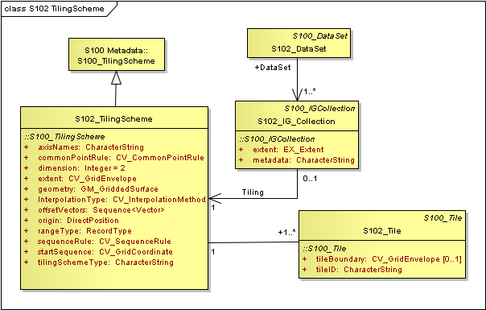
Figure 5 - S-102 Tiling Scheme

Table 2 provides a description of each attribute of the S102_TilingScheme class attributes.

Table 2 - Tiling Scheme description

Role  Name | Name | Description | Cardina lity | Type | Remarks
Class | S102_TilingScheme | Container class for tiling scheme description | - | -
attribute | tilingSchemeType | description of the type of the tiling scheme | 1 | CharacterString | "uniform quadrilateral grid"
attribute | domainExtent | description of the extent of  the tiling scheme | 1 | EX_Extent
attribute | rangeType | description of the range of the coverage | 1 | RecordType | the record value  for each grid cell in a tiling scheme consists of a single entry corresponding to the tile,
attribute | commonPointRule | procedure to be used for evaluating the CV_Coverage at a position that falls on a boundary between tiles or within the boundaries of two or more overlapping tiles | 1 | CV_CommonPointRule | For tiles (not the  data within a tile)  the result is "all". That is, both tiles apply and are returned by a tiling scheme coverage function. The application will determine which  to use.
attribute | geometry | geometry of the domain object | 1 | GM_GriddedSurface
attribute | interpolationType | identification of interpolation method | 1 | CV_InterpolationMethod | not applicable, Tiles cannot be interpolated
attribute | dimension | dimensionality of the grid | 1 | Integer | default = 2  No other value is allowed.
attribute | axisNames | names of the grid axis | 1 | CharacterString | The grid axis  names are by default "Longitude" and  "Latitude" but may be different if, for example, the grid  is at a different orientation.
attribute | origin | position that locates the origin of the rectified grid  in the coordinate reference system | 1 | DirectPosition
attribute | offsetVectors | a 2 dimensional vector  quantity that determine the grid spacing in each  direction | 1 | Sequence <Vector>
attribute | extent | description of the extent of the tiling scheme | 1 | CV_GridEnvelope
attribute | sequenceRule | describe how the grid points are ordered for association to the elements of the sequence values. | 1 | CV_SequenceRule | The default value is "Linear" which  is used for a  uniform quadrilateral grid tile coverage.  No other value is allowed.
attribute | startSequence | the grid point to be associated with the first record in the values  sequence | 1 | CV_GridCoordinate | The default value is the lower left corner of the grid

Feature Catalogue

Introduction
S-102 is a coverage feature product. The content information is described in terms of a coverage feature model and a feature catalogue. Note, for Imagery and Gridded Data, a coverage is a type of feature. Therefore this product specification will only contain a limited catalogue.

Feature Types

Coverage
A coverage is a type of feature so a Bathymetry Surface Product specification does contain features. There are four coverages defined which along with the associated metadata are the Bathymetry Surface Product Specification. The bathymetry depth coverage and the uncertainty coverage and any optional surface coverage are discrete coverages. The third coverage is the discrete point coverage that corresponds to the tracking list of original values and uncertainties. These three entries compose the feature catalogue.

Meta
No meta features exist within the S-102 Product Specification.

Feature Relationship
A feature relationship links instances of one feature type with instances of the same or a different feature type. S-102 uses only one type of feature relationship, : Association.
4.3.3.1 Association
An association is used to describe a relationship between two feature types that defines relationships between their instances.
Example: A S102_IGCollection may contain a (0 or 1) S102_TilingScheme.
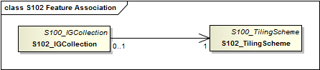
Figure 6: Feature Association

Attributes
S-102 defines attributes as either simple or complex.

Simple Attributes
S-102 uses the following simple attribute types.
Type | Definition
Enumeration | A fixed list of valid identifiers of named literal values
Boolean | A value representing binary logic. The value can be either True or False. The default state for Boolean type attributes (i.e. where the attribute is not populated for the feature) is False.
Decimal | A signed Real (floating point) number consisting of a mantissa and an exponent
Integer | A signed integer number. The representation of an integer is encapsulation and usage dependent.
CharacterString | An arbitrary-length sequence of characters including accents and special characters from a repertoire of one of the adopted character sets
Date and Time | A DateTime is a combination of a date and a time type. Character encoding of a DateTime must follow ISO 8601:1988  EXAMPLE 19850412T101530

4.3.4.2 Complex Attributes
Complex attributes are aggregations of other attributes that are either simple or complex. The aggregation is defined by means of bindings.

S-102 Coverages
The major components of the Bathymetric Surface product are the coverages. At a minimum a Bathymetric Surface product (called a Bathymetric Attributed Grid (BAG)) must have two coverages. The general structure of each is defined in IHO S-100 Part 8 as a georectified grid. Metadata defining the axes, dimensions, and geolocation parameters are found in the metadata in the MD_GridSpatialRepresentation and other classes defined in ISO 19115. Furthermore the two coverages are co-located. Each of these contains a two-dimensional matrix organized in row major order, and starting from the south-western most data point, where each value is defined to be at an exactly specified geographic point (or grid node), hence negating the need for horizontal uncertainties

The units of the elevation values are metres, and the sign convention is for z to be positive for values above the vertical datum. The reference vertical datum for the BAG is one of the mandatory Metadata items. This sign convention follows directly from the right hand coordinate system definition to which the standard adheres.

The unknown state for elevation is defined to be 1,000,000.0 (1.0e6).

The uncertainty values are expressed as positive quantities at a node. As detailed in clause 12.2 the uncertainty grid supports multiple definitions of vertical uncertainty. This allows BAGs to span the expected range of data products from raw, full resolution grid to final compiled product. For example, a BAG at the stage of final survey data processing should contain uncertainty information germane to the survey data itself and intended to be used for information compilation. A recipient of a BAG file can refer to the uncertainty definition in the Metadata to gain an understanding of how the uncertainty was computed.

The undetermined state for uncertainty is defined to be 1,000,000.0 (1.0e6).

The values associated with the optional coverages, with the exception of “Nominal Elevation” are expressed as positive quantities at a node. Nominal Elevation is an elevation coverage where the depths would be resolved by a fathometer assuming a sound velocity of 1500 m/sec. The type of parameter associated with the values of an optional coverage are described in clause 4.2.1. .

The undetermined state for any optional value is defined to be 1,000,000.0 (1.0e6).

Tracking List
The tracking list contains a simple list of the original elevation and uncertainty values from any node of the surface that has been modified to account for hydrographer over-rides of the basic surface definition (e.g., as originally computed by an algorithmic method). The tracking list dataset and corresponding information contained in the metadata exist to provide an audit trail record of changes made to the data by manual intervention.

Surface Corrections
The purpose of this optional dataset is to preserve vertical surface corrections. The dataset can have one or more values per point for performing the vertical transformation from the elevation vertical datum to other user-specified datum(s). The optional dataset supports any floating point value, so corrections to other surfaces, like uncertainty, can also be stored in the same dataset. This dataset will likely be sparser than the full resolution grid spacing of the elevation, uncertainty, and other optional data surfaces.
A regularly spaced grid topography or a set of irregularly spaced coordinates, represented as a point coverage, may comprise this dataset. The intended approach is that the S-102 producer provides sufficient data density to allow a simplistic inverse distance interpolation scheme so that correction values can be computed any of the elevation nodes.

Extensions
The Bathymetric Surface Product Specification is extensible. This includes both extensions to the content model and to the encodings supporting the content model. Extensions are optional coverages and not required for a file to be qualified nor do they invalidate a compliant product. Additional layers of information not related to the bathymetric scope of this product specification should be defined in separate S.100 and S.10x compliant layers.

Dataset Types
In order to facilitate the efficient processing of S-102 data the geographic coverage of a given maximum Display Scale may be split into multiple datasets.
The discovery or exchange metadata of a dataset must list all extents or the Data Coverage features contained within that dataset and their assigned scale attributions.

Data Coverage rules
Each S-102 dataset must only have a single extent as it is a coverage feature.
Datasets with the same maximum display scale may overlap, however the set of all extents these datasets must not overlap. This rule applies even if several producers are involved. There must be no overlapping data of the same maximum Display Scale, except at the agreed adjoining national data limits, where, it is difficult to achieve a perfect join, a buffer to be agreed to by the national authorities may be used in this situation.

Dataset Loading and Unloading
A new algorithm based on producer defined dataset display scales (minimum and maximum) for dataset loading and unloading within a navigation system is prescribed in S-102 in order for the appropriate coverage to be viewed at the mariner’s selected viewing scale. This will simplify the process for navigation systems, giving clear and concise rules on how and when data is loaded and unloaded.

Dataset Loading and Unloading Algorithm
This clause defines the dataset loading and unloading algorithm for use within navigation systems.
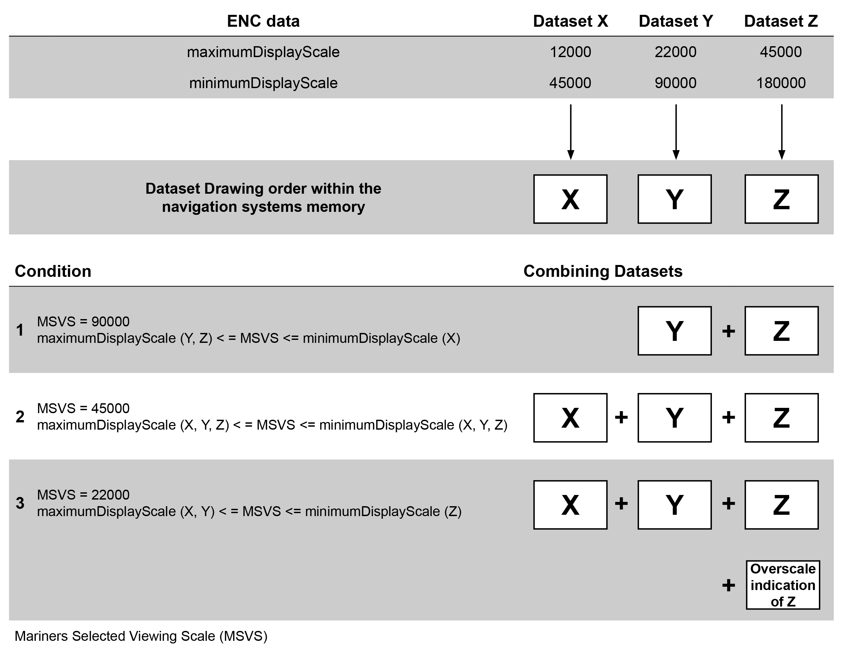
Figure 7 - Data Loading and Unloading Algorithm

In order for systems to properly load and unload data as the mariner is zooming in and out using the mariner’s selected viewing scale (MSVS) the following algorithm must be used.
- 1. Create selection List
a. All Data Coverage areas within the graphics window within scale range (covered by the MSVS) are firstly ordered by maximum Display Scale and secondly by the largest percentage of coverage if Data Coverage areas have the same maximum Display Scale
b. All other smaller scale Data Coverage areas within the graphics window are firstly ordered by maximum Display Scale and secondly by the largest percentage of coverage if Data Coverage areas have the same maximum Display Scale
c. The display order is from the smallest maximum Display Scale to the largest maximum Display Scale, that is the Data Coverage area with largest maximum Display Scale will be displayed with the highest priority
2. If the MSVS is larger than the maximum Display Scale of an area within the window, turn on overscale indication.
3. If the mariner selects an individual dataset to load it must be displayed at its maximum Display Scale, that is MSVS is set to the maximum Display Scale of the selected dataset, and then the algorithm is used to fill the graphics window.
The example below works through four scenarios and uses four different types of Data Coverage with different maximum Display Scale and minimum Display Scale. They are denoted as areas A, B, C and D.
NOTE: this example is applicable to multiple datasets with overlapping Data Coverages.
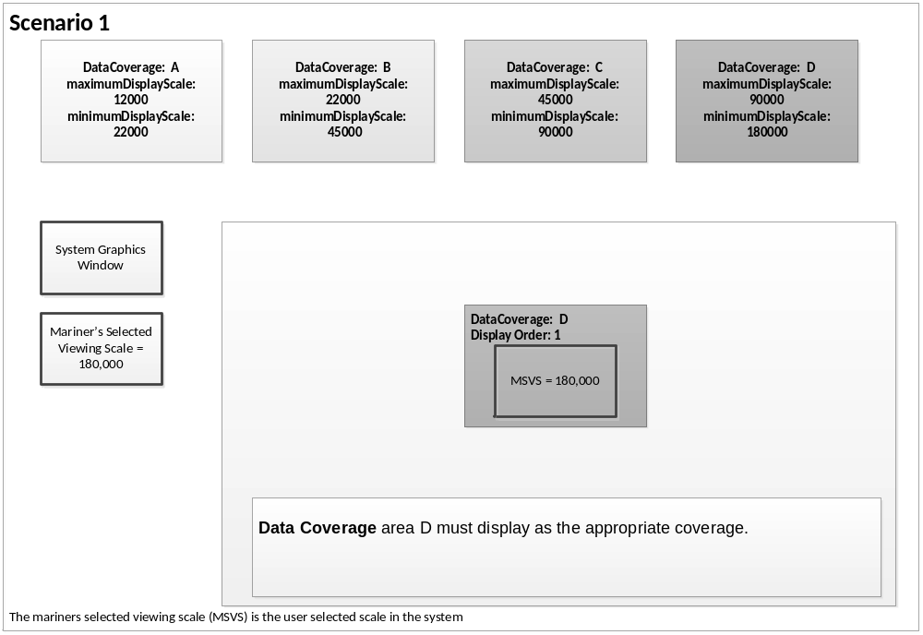
Figure 8 – Scenario 1: Simple Data Coverage Display
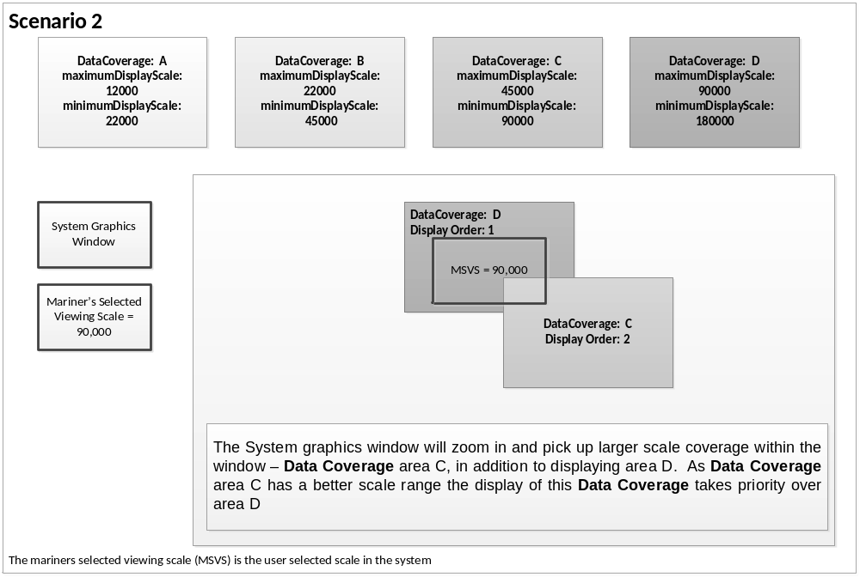Figure 9 - Scenario 2: Display of two different overlapping Data Coverages

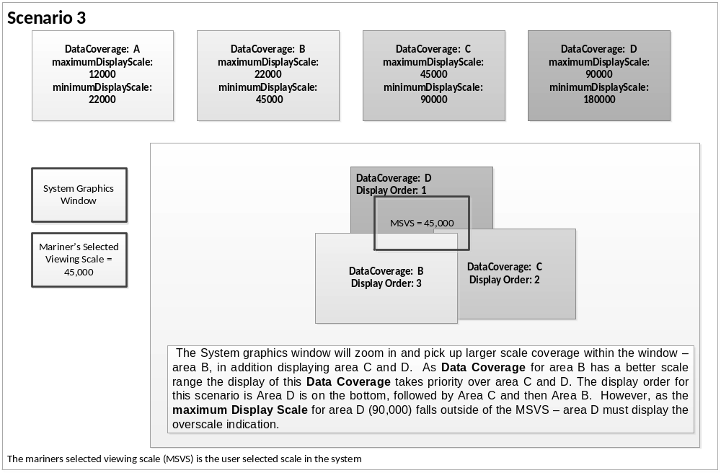Figure 10 - Scenario 3: Display of three different overlapping Data Coverages
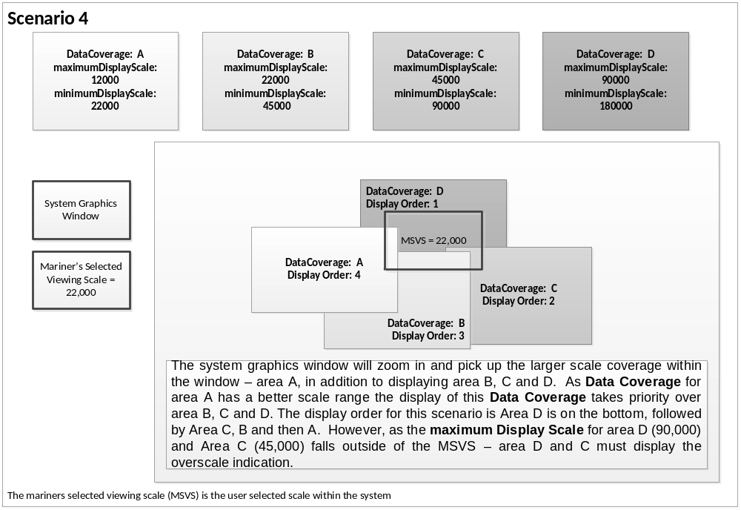Figure 11 - Scenario 4: Display of four different overlapping coverages

Coordinate Reference Systems (CRS)

Introduction
The geo-referencing for a S-102 Bathymetric Surface product shall be node-based, referenced from the southwestern-most node in a grid. Each sample in a grid represents the value in the grid at a point location at the coordinate specified, rather than an estimate over any area with respect to the coordinate. The reference position included in the metadata shall be given in the coordinates used for the grid, and shall contain sufficient digits of precision to locate the grid with accuracy no worse than a decimeter on the surface of the ellipsoid of rotation of the chosen horizontal datum.

The Coordinate Reference System information is defined in the manner specified in S-100. The coverage can be specified in any projected coordinate system supported in IHO S-100 Part 6. However, no transformation methods are provided. Note the vertical datum is defined through a second association role to a vertical reference system.

Spatial reference system:
All coverages in the Bathymetric Surface Product Specification are georectified, simple uniform quadrilateral grids as defined in IHO S-100 Part 8.

All S-102 Bathymetric Surface product coverages shall be represented with a right-handed Cartesian coordinate system. This system shall have the x-axis oriented towards positive eastings (for projected grids), or east (for geographic grids), and y-axis oriented towards positive northings (for projected grids), or north (for geographic grids). These definitions imply that the z-axis for the sounding data is positive away from the center of mass of the earth (i.e., is positive up), rather than the usual hydrographic convention of positive down (i.e., deeper depths are larger numbers and negative depths are above datum). User-level code is free to make this reflection if required, but must write the data using the positive-up convention. In order to make this distinction clear, the term elevation is used for the vertical component of the BAG, rather than depth. The uncertainty component of the BAG shall have the same coordinate system as the elevation component, with the exception that the z-axis is unipolar, and therefore the concept of direction of positive increase is irrelevant.

The grid data in a S-102 Bathymetric Surface coverage (either elevation or uncertainty, and any other surfaces that may be added) shall be organized as a uniform quadrilateral grid in row-major order from west to east, and south to north Thus, the first sample of the grid is the node at the southwest corner of the grid with location as specified by the georeferencing parameters, the second is one grid resolution unit to the east of that position and at the same northing or latitude, and the third is two grid resolution units to the east and at the same northing or latitude. For C columns in the grid, the (C+1)th sample in the grid is located one grid resolution unit to the north, but on the same easting, or longitude, as the first sample in the grid.

Horizontal Coordinate Reference System
For ENC the horizontal CRS must be EPSG:4326 (WGS84). The full reference to EPSG: 4326 can be found at www.epsg-registry.org.

Horizontal coordinate reference system: EPSG:4326 (WGS84)
Projection: None
Temporal reference system: Gregorian calendar
Coordinate reference system registry: EPSG Geodetic Parameter Registry
Date type (according to ISO 19115): 002- publication
Responsible party: International Organisation of Oil and Gas Producers (OGP) URL: http://www.iogp.org

Data Quality
As defined in IHO S-100 Part 4c the data quality for the elevation coverage is also defined as a co- located coverage, uncertainty. Uncertainty is defined as the vertical uncertainty at each node location. The uncertainty coverage supports multiple definitions of vertical uncertainty.

Data Capture and Classification
There are a number of sounding techniques, including SONAR and LIDAR that are used to capture bathymetric data. It is permitted, but not required, to include data acquisition information in the metadata of an S-102 Bathymetric Surface product. The metadata class S102_AcquisitionMetadata has been defined, but the information elements to populate this metadata class should be identified in a national profile of S-102.

Maintenance
Maintenance and Update Frequency:
Data Source:
Production Process:
S-102 data sets are maintained by replacement on a tile or dataset basis. That is, the entire data product or tile within a data set including its coverages (elevation/depth, uncertainty, and tracking list point set coverage) and the associated metadata are replaced as a unit. This is unlike S-101 vector data that may be updated incrementally. However, coverage data must be considered as a unit at least at the tile level. This is because processing is done on the entire tile to produce the data product. Any replacement tile will include its own tracking list (when a tracking list is used) to deliberately bias the information for safety of navigation. Also each replacement tile or data set must have its own digital signature.

Portrayal
9.1 Introduction
S-102 portrayal is intended to contribute to the safe operation of a S-100 based ECDIS. The Bathymetric Surface will be portrayed using two methods. Those are:
- A ramp of colors cut into the ENC replacing skin-of-the-Earth features;
- A two color scheme depicting safe/unsafe waters based on a mariner provided context parameter.

<TBD – set of portrayal rules, drawing instructions and color palletes need to be defined in S-100 Part 8 if a portrayl catalogue is to be defined. Note, Part 8.9 references ISO – 19117.>

Data Product format (encoding)

Introduction
Format Name: HDF-5
Version: 1.8
Character Set: UTF-8
Specification: https://www.hdfgroup.org

Data Product Delivery

Introduction
Units of Delivery: Exchange Set
Transfer Size: Unlimited
Medium Name: Digital data delivery
Other Delivery Information:
Each dataset must be contained in a physically separate, uniquely identified file on the transfer medium.
Each exchange set has a single exchange catalogue which contains the discovery metadata for each dataset and references to any support files.
An exchange set is encapsulated into a form suitable for transmission by a mapping called an encoding. An encoding translates each of the elements of the exchange set into a logical form suitable for writing to media and for transmission online. An encoding may also define other elements in addition to the exchange set contents (This is media identification, data extents etc…) and also may define commercial constructs such as encryption and compression methods.
If the data is transformed in S-102 it must not be changed.
This product specification defines the encoding which must be used as a default for transmission of data between parties.
The encoding encapsulates exchange set elements as follows:
Mandatory Elements
- S-102 datasets – HDF encoding
- Exchange Catalogue – the XML encoded representation of exchange set catalogue features [discovery metadata].
Optional Elements
- S-102 Feature Catalogue – If it is necessary to deliver the latest feature catalogue to the end user it may be done using the S-102 exchange set mechanism for datasets
- S-102 Portrayal Catalogue - If it is necessary to deliver the latest portrayal catalogue to the end user it may be done using the S-102 exchange set mechanism for datasets.

Dataset

Datasets
Two types of dataset files may be produced and contained within an exchange set:

- New dataset and new edition of a dataset (base dataset): Including new information which has not been previously distributed by updates. Each new edition of a dataset must have the same name as the dataset that it replaces.

- Cancellation: The dataset is cancelled and is deleted from the system.

Dataset size

Datasets must not exceed 10MB.

Dataset file naming
CCXXXXXXXX.EEE

The file name forms a unique identifier where:
- CC - the first two characters identify the issuing agency (mandatory).
- the third to tenth characters are optional and may be used in any way by the producer to provide the unique file name. The following characters are allowed in the dataset name, A to Z, 0 to 9 and the special character _ (underscore).
- .EEE – new editions and re-issues use 102 (mandatory).
- the maximum number of characters is ten.

Exchange Catalogue

The exchange catalogue acts as the table of contents for the exchange set. The catalogue file of the exchange set must be named S102ed1.CAT. No other file in the exchange set may be named S102ed1.CAT. The contents of the exchange catalogue are described in Clause 12.

Metadata

Introduction
The Metadata elements used in the Bathymetric Surface product are derived from S-100 and from
ISO 19115 and ISO 19115-2. Optionally additional metadata may be derived from ISO 19130 and ISO
19130-22 especially metadata relating to the SONAR equipment which may have been used to acquire the bathymetric data.

There are only a few elements in the ISO 19115 metadata standard that are mandatory and these relate only to the use of the metadata for identification and pedigree of the data set. A minimum level of data identification is required for all applications including database applications, web services and data set production. However, S-102 requires certain metadata attributes which are used to geolocate the dataset as well as lineage attribution which define processes used to establish the tracking list and establish a pedigree for the data.

The elements are related in a metadata schema, and include definitions and extension procedures. There exist both mandatory and conditional metadata elements. Only a few metadata elements are mandatory but the inclusion of some of the optional metadata elements establish a situation where other metadata elements are conditionally made mandatory.

The following table outlines the core metadata elements (mandatory and recommended optional) required for describing a geographic information data set. The codes indicate: "M" mandatory, "O" optional' "C" conditional as defined in ISO 19115. The table indicates how the mandatory and conditional core metadata are handled in S-102.

Dataset title (M)  S102_DS_DiscoveryMetadata > citation > CI_Citation.title  from: (MD_Metadata > MD_DataIdentification.citation > CI_Citation.title) | Spatial representation type (O)  S102_DS_DiscoveryMetadata > spatialRepresentationType : MD_ SpatialRepresentationType Code  002– Grid; (for quadrilateral grid coverage)  001– Vector; (for tracking list discrete point coverage)  from: (MD_Metadata > MD_DataIdentification.spatialRepresentationType)
Dataset reference date (M)  S102_DS_DiscoveryMetadata > citation > CI_Citation.date  from: (MD_Metadata > MD_DataIdentification.citation > CI_Citation.date) | Reference system (O) S102_StructureMetadataBlock > hRefSystem and S102_StructureMetadataBlock > vRefSystem  from: (MD_Metadata > MD_ReferenceSystem)
Dataset responsible party (O)  S102_DS_DiscoveryMetadata >  pointOfContact > CI_ ResponsibleParty  from: (MD_Metadata > MD_DataIdentification.pointOfContact > CI_ResponsibleParty) | Lineage (C)  S102_QualityMetadataBlock > S102_LI_Source and  S102_QualityMetadataBlock > S102_LI_ProcessStep  from: (MD_Metadata > DQ_DataQuality.lineage > LI_Lineage)
Geographic location of the dataset (by four coordinates or by geographic identifier) (C)  S102_DS_DiscoveryMetadata > extent > EX_Extent  from: (MD_Metadata > MD_DataIdentification.extent > EX_Extent > EX_GeographicExtent > EX_GeographicBoundingBox or EX_GeographicDescription ) | On-line resource (O)  (MD_Metadata > MD_Distribution > MD_DigitalTransferOption.onLine > CI_OnlineResource)  Optional - not required
Dataset language (M)  S102_DS_DiscoveryMetadata > language from: (MD_Metadata >  MD_DataIdentification.language) | Metadata file identifier (O)  (MD_Metadata.fileIdentifier)  Implicit in S-102 product specification reference to ISO  19115 as a normative reference
Dataset character set (C)  set to default = "utf8". [not required when set to default from ISO 19115]  from: (MD_Metadata > MD_DataIdentification.characterSet) | Metadata standard name (O)  (MD_Metadata.metadataStandardName)  Implicit in S-102 product specification reference to ISO  19115 as a normative reference
Dataset topic category (M)  S102_DS_DiscoveryMetadata >  topicCategory: MD_TopicCategoryCode  006– elevation;  012– oceans;  014– inlandWaters  [see clause 8.5]  from: (MD_Metadata > MD_DataIdentification.topicCategory) | Metadata standard version (O)  (MD_Metadata.metadataStandardVersion)  Implicit in S-102 product specification reference to ISO  19115 as a normative reference
Spatial resolution of the dataset  (O)  (MD_Metadata > MD_DataIdentification.spatialResolution > MD_Resolution.equivalentScale or MD_Resolution.distance)  Since this data set is a grid coverage resolution is defined by the coveraqe grid parameters. | Metadata language (C)  (MD_Metadata.language)  The language is set to English. In addition additional languages may be used in accordance with the structure for handling multi-languages per ISO 19115  Annex J.
Abstract describing the dataset  (M)  S102_DS_DiscoveryMetadata > abstract from: (MD_Metadata >  MD_DataIdentification.abstract) | Metadata character set (C)  set to default = "utf8". [not required when set to default from ISO 19115]  from: (MD_Metadata.characterSet)
Distribution format (O)  (MD_Metadata > MD_Distribution > MD_Format.name and MD_Format.version)  Optional - not applicable  to maintain the separation of carrier and content the content model does not contain any format information. This would be included in a transmittal or by file types. | Metadata point of contact (M)  S102_DS_DiscoveryMetadata > contact  from: (MD_Metadata.contact > CI_ResponsibleParty)
Additional extent information for the dataset (vertical and temporal) (O)  (MD_Metadata > MD_DataIdentification.extent > EX_Extent > EX_TemporalExtent or EX_VerticalExtent)  Optional - not required | Metadata date stamp (M) S102_DS_DiscoveryMetadata > dateStamp from: (MD_Metadata.dateStamp)

Discovery Metadata
Metadata is used for a number of purposes. One high level purpose is for the identification and discovery of data. Every data set needs to be identified so that it can be distinguished from other data sets and so it can be found in a data catalogue, such as a Web Catalogue Service. The discovery metadata applies at the S102_DataSet level and at the S102_IG_Collection level. That is, there is discovery data for the whole data set and for those data sets that are composed of several tiles there is also equivalent discovery metadata for each tile.

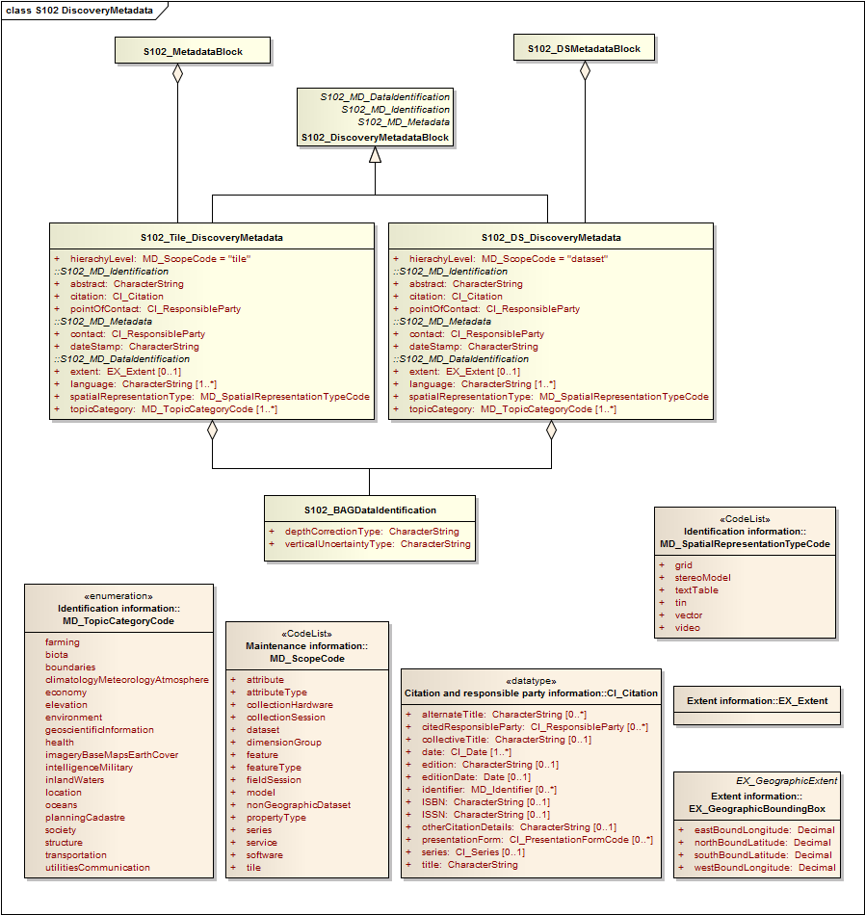
Figure 12 – S-102 Discovery Metadata

Figure 12 shows the S102_DiscoveryMetadataBlock. It has two subtypes S102_DS_DiscoveryMetadata and S102_Tile_DiscoveryMetadata. The only difference is that the hierachyLevel code is set to "dataset" for the whole data set and "tile" for a tile. These two classes implement the metadata classes from ISO 19115. First implementation classes have been developed corresponding to each of the ISO 19115 classes that have been referenced in which only the applicable attributes have been included. The classes S102_DS_DiscoveryMetadata and S102_Tile_DiscoveryMetadata inherit their attributes from these S-102 specific implementation classes. In addition an additional component S102_BAGDataIdentification has been added.

This model provides the minimum amount of metadata for a Bathymetry Surface data product. Any of the additional optional metadata elements from the source ISO 19115 metadata standard can also be included.

Table 3 provides a description of each attribute of the S102_DiscoveryMetadataBlock class attributes.

Role  Name | Name | Description | Cardina lity | Type | Remarks
Class | S102_DiscoveryMetadata  Block | Container class for  discovery metadata | - | -
Class | S102_DS_DiscoveryMeta data | Container class for  discovery metadata related to an entire data set | - | -
Class | S102_Tile_DiscoveryMeta data | Container class for  discovery metadata related to a particular tile  when there are multiple  tiles in a data set. | - | -
attribute | hierachyLevel |  | 1 | MD_ScopeCode | "dataset" for  S102_DS_Discov eryMetadata or  "tile" for  S102_Tile_Discov eryMetadata
attribute | contact | party responsible for the  metadata information | 1 | CI_ResponsibleParty
attribute | dateStamp | date that the metadata  was created | 1 | CharacterString
attribute | abstract | brief narrative summary of the  content of the resource(s) | 1 | CharacterString
attribute | citation | citation data for the resource(s) | 1 | CI_Citation | CI_Citation  <<DataType>> Required items  are Citation.title, & Citation.date,
attribute | pointOfContact | identification of, and  means of communication with,  person(s) and organization(s) associated  with the resource(s) | 1 | CI_ResponsibleParty | CI_ResponsibleP  arty  <<DataType>>
attribute | language | language(s) used within the  dataset | 1-* | CharacterString | ISO 639-2 list of languages, default "English" plus  others as used.
attribute | topicCategory | main theme(s) of the dataset | 1-* | MD_TopicCategoryCode | MD_TopicCategor  yCode  <<Enumeration>>  006– elevation;  012– oceans;  014–  inlandWaters
attribute | extent | extent information including the  bounding box, bounding  polygon,  vertical, and temporal extent of the  dataset | 0-1 | EX_Extent | EX_Extent  <<DataType>>
attribute | spatialRepresentationType | method used to spatially represent  geographic information | 1 | MD_SpatialRepresentati onTypeCode | MD_SpatialRepre  sentation  TypeCode  <<CodeList>>  002– Grid; (for quadrilateral grid coverage)  001– Vector; (for tracking list discrete point  coverage)
Class | S102_BAGDataIdentificati on | component for  S102_DiscoveryMetadata  Block. Extension beyond  ISO 19115 metadata | - | -
attribute | depthCorrectionType | code defining the type of sound velocity correction made to the depths | 1 | CharacterString | see table 4
attribute | verticalUncertaintyType | code defining how  uncertainty was determined | 1 | CharacterString | see table 5

The class S102_BAGDataIdentification provides an extension to the metadata available from ISO
19115. The verticalUncertaintyType attribute was added to allow the BAG to accurately describe the source and meaning of the encoded Uncertainty coverage. The depthCorrectionType was also added to define if and how the elevations are corrected (i.e. true depth, depth ref 1500 m/sec, etc.). Tables 4 and 5 provide a description.

Table 4 - Code defining the type of sound velocity correction

Value | Definition
SVP_Applied | Sound velocity field measured and applied (True Depth).
1500_MS | Assumed sound velocity of 1500 m/s used.
1463_MS | Assumed sound velocity of 1463.04 m/s used (Equivalent to 4800 ft/s).
NA | Depth not measured acoustically.
Carters | Depths corrected using Carter‘s Tables.
Unknown

Table 5 - Code defining how uncertainty was determined

Value | Definition
Unknown | "Unknown" - The uncertainty layer is an unknown type
Raw_Std_Dev | "Raw Standard Deviation" - Raw standard deviation of  soundings that contributed to the node.
CUBE_Std_Dev | Dev "CUBE Standard Deviation " - Standard deviation of soundings captured by a  CUBE hypothesis (i.e., CUBE‘s standard output of uncertainty)
Product_Uncert | "Product Uncertainty" - NOAA standard product uncertainty  V1.0 (a blend of CUBE uncertainty and other measures).
Historical_Std_Dev | "Historical Standard Deviation " – Estimated standard deviation based on  historical/archive data.

Structure Metadata
Structure metadata is used to describe the structure of an instance of a collection, including any reference to a tiling scheme. Since constraints can be different on separate files (for example they could be derived from different legal sources), or security constraints may be different, the constraint information becomes part of the structure metadata. The other structure metadata is the grid representation and the reference system.

Figure 13 shows the S102_StructureMetadataBlock. The metadata block is generated by the inheritance of attributes from a number of ISO 19115 metadata classes, and S-100 class for tiling and two implementation classes for the horizontal and vertical reference system. This makes the metadata block a simple table.

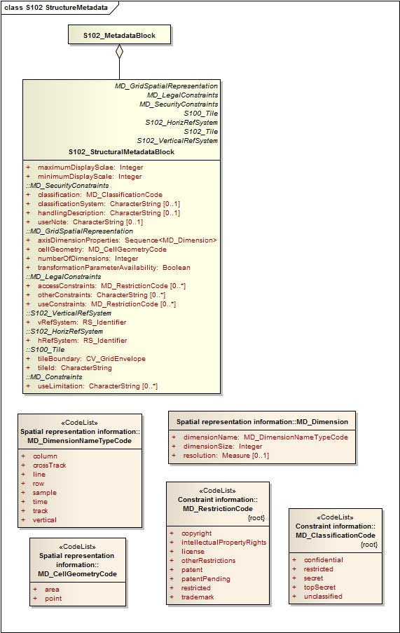
Figure 13 – S-102 Structure Metadata

Table 6 provides a description of each attribute of the S102_StructureMetadataBlock class attributes.

Role  Name | Name | Description | Cardina lity | Type | Remarks
Class | S102_StructuralMetadata  Block | Container class for  structural metadata | - | -
attribute | maximumDisplayScale | Maximum display scale for the elevation coverage. | 1 | Integer
attribute | minimumDisplayScale | Minimum display scale for the elevation coverage. | 1 | Integer
attribute | numberOfDimensions | number of independent  spatialtemporal axes | 1 | Integer | default = 2  No other value is allowed.
attribute | axisDimensionProperties | information about spatial- temporal  axis properties | 1 | MD_Dimension | MD_Dimension  <<DataType>>  dimensionName and  dimensionSize
attribute | cellGeometry | identification of grid data as point or cell | 1 | MD_CellGeometryCode | MD_CellGeometry  Code  default = point  No other value is allowed.
attribute | transformationParameterA  vailability | indication of whether or  not parameters for transformation between image coordinates and geographic or map coordinates  exist (are available) | 1 | Boolean | 1 = yes 0 = no Mandatory and must be 1.
attribute | vRefSystem | name of vertical reference system | 1 | RS_Identifier | reference system vertical  information, can also be defined explicitly by use of  the parameters in  19111
attribute | hRefSystem | name of horizontal reference system | 1 | RS_Identifier | default = WGS84. reference system horizontal  information, can also be defined explicitly by use of  the parameters in  19111.
attribute | accessConstraints | Access constraints applied to assure the protection of privacy or intellectual  property, and any special restrictions or limitations on obtaining the dataset. | 0-* | MD_RestrictionCode
attribute | useConstraints | Constraints applied to assure the protection of privacy or intellectual  property, and any special restrictions or limitations or warnings on using the  dataset | 0-* | MD_RestrictionCode
attribute | otherConstraints | Other restrictions and  legal prerequisites for accessing and using the dataset | 0-* | CharacterString
attribute | classification | Name of the handling  restrictions on the dataset | 1 | MD_ClassificationCode
attribute | userNote | Additional information  about the classification | 0-1 | CharacterString
attribute | classificationSystem | Name of the classification  system | 0-1 | CharacterString
attribute | handlingDescription | Additional information  about the restrictions on handling the dataset | 0-1 | CharacterString
attribute | tileID | tile identifier | 1 | CharacterString
attribute | tileBoundary | tile boundary | 0-1 | GM_Curve | When not provided is assumed to be the extent of the collection asdefined by EX_Extent
Class | MD_Dimension | Axis properties | - | -
attribute | dimensionName | name of axis | 1 | MD_DimensionTypeCod e | Defaults are "row" and "column" Not other value is allowed.
attribute | dimensionSize | number of elements along the axis | 1 | Integer
attribute | resolution | degree of detail in the grid dataset | 0-1 | Measure | value= number

Quality Metadata
Quality metadata is used to describe the quality of the data in an instance of a collection. Figure 7 shows the S102_QualityMetadataBlock. The S102_QualityMetadataBlock derives directly from the ISO 19115 class DQ_DataQuality. However its components S102_LI_Source and S102_LI_ProcessStep are generated by the inheritance of attributes from the ISO 19115 classes LI_Scope and LI_ProcessStep. Only some of the attributes of the referenced ISO 19115 classes are implemented. In addition the class S102_Bag_ProcessStep has been added. This extension allows internal Tracking List entries to be associated with a unique entry in the metadata so that the changes can be properly attributed, described and easily referenced.

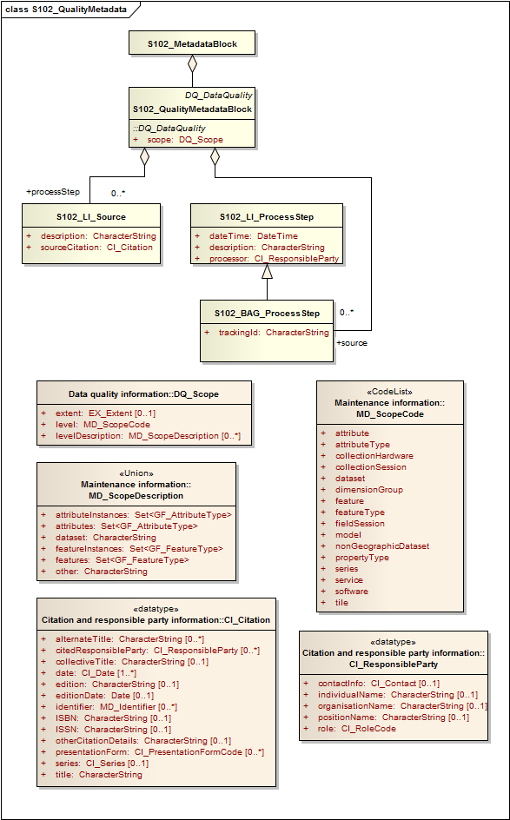
Figure 14 S-102 Quality Metadata
Table 7 provides a description of each attribute of the S102_QualityMetadataBlock class attributes and those of its components.

Table 7 - Quality Metadata Block description

Role  Name | Name | Description | Cardina lity | Type | Remarks
Class | S102_QualityMetadataBlo  ck | Container class for quality  metadata | - | -
attribute | scope | extent of characteristic(s)  of the  data for which quality information  is reported | 1 | DQ_Scope
Class | S102_LI_Source | information about the  source data  used in creating the data specified  by the scope | - | -
attribute | description | detailed description of the  level of  the source data | 1 | CharacterString
attribute | sourceCitation | recommended reference  to be used for the source data | 1 | CI_Citation
Class | S102_LI_ProcessStep | information about an event or transformation in the life of a dataset including the  process used to maintain the dataset | - | -
attribute | dateTime | date and time or range of date and  time on or over which the  process  step occurred | 1 | CharacterString
attribute | description | description of the event, including  related parameters or  tolerances | 1 | CharacterString
attribute | processor | identification of, and  means of communication with,  person(s) and organization(s) associated  with the process step | 1 | CI_ResponsibleParty
Class | S102_BAG_ProcessStep | Management of TrackingList references to LI_ProcessStep | - | -
attribute | trackingId | ID reference used so that  Tracking List entries can be associated with a  unique entry in the metadata so that the  changes can be properly attributed, described and easily referenced | 1 | CharacterString
Class | DQ_Scope | Container class for quality  metadata | - | -
attribute | level | hierarchical level of the  data  specified by the scope | 0-* | MD_ScopeCode  <<CodeList>> | "dataset" or "tile"
attribute | extent | information about the  horizontal,  vertical and temporal extent of the  data specified by the  scope | 0-* | EX_Extent  <<DataType>> | Used only if the extent of the data is different from the EX_Extent given for the collection / tile
attribute | levelDescription | detailed description about the level  of the data specified by  the scope | 1 | MD_ScopeDescription  <<Union>>

Acquisition Metadata
Acquisition metadata to a Bathymetric Surface Product Specification profile that they are developing nationally. The classes derive from ISO 19115, 19115-2, 19130 and 19130-2. The later document 19130-2 contains description of SONAR parameters.

Exchange Set Metadata
For information exchange, there are several categories of metadata required: metadata about the overall exchange catalogue, metadata about each of the datasets contained in the catalogue, and metadata about the support files that make up the package.
This clause defines the mandatory and optional metadata needed for S-102 exchange set metadata. In some cases the metadata may be repeated in a national language. If this is the case it is noted in the Remarks column.
Figures 15 to 19 outline the overall concept of an S-102 exchange set for the interchange of geospatial data and its relevant metadata. Figure 18 depicts the realization of the ISO 19139 classes which form the foundation of the exchange set. The overall structure of S-102 metadata for exchange sets is modelled in Figures 19 and 20. More detailed information about the various classes is shown in Figure 19 and a textual description in the tables at clause 12.5.
The discovery metadata classes have numerous attributes which enable important information about the datasets and accompanying support files to be examined without the need to process the data, for example, decrypt, decompress, load etc. Other catalogues can be included in the exchange set in support of the datasets such as feature and portrayal. The attribute “purpose” of the support file metadata provides a mechanism to update support files more easily.

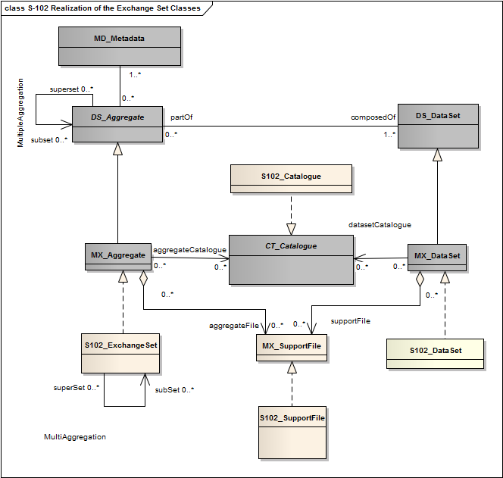
Figure 15 Realization of the Exchange Set Classes
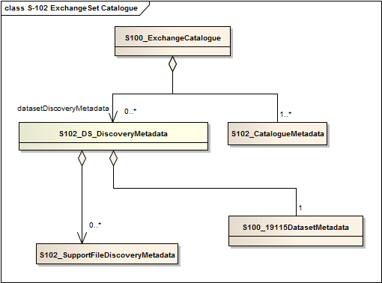
Figure 16 – S-102 ExchangeSet Catalogue

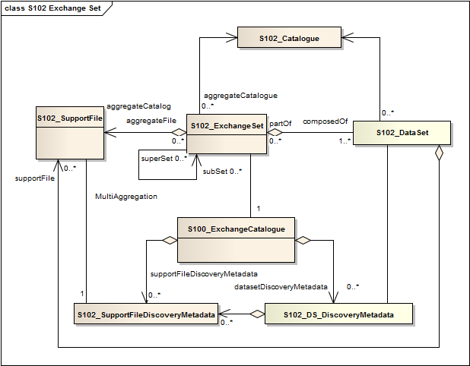
Figure 17 - S-102 Exchange Set

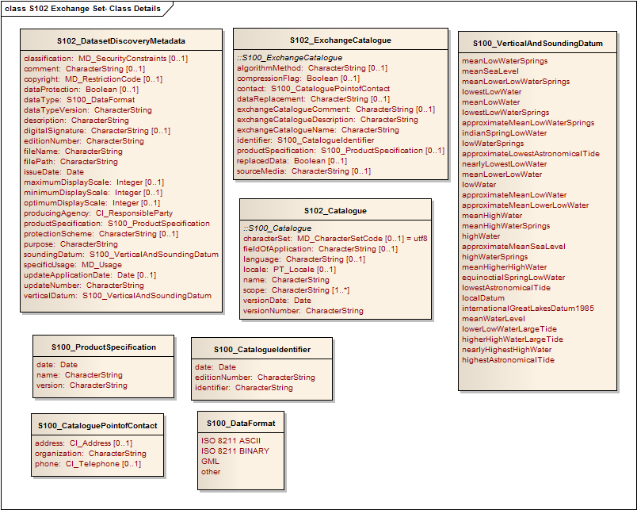
Figure 18 S-102 Exchange Set - Class Details

The following clauses define the mandatory and optional metadata needed for S-102. In some cases the metadata may be repeated in a national language. If this is the case it is noted in the Remarks column.

S102_ExchangeCatalogue
Each exchange set has a single S102_ExchangeCatalogue which contains meta information for the data and support files in the exchange set.

Name | Description | Mult | Type | Remarks
S102_ExchangeCatalogue | An exchange catalogue contains the discovery metadata about the exchange datasets and support files | - | - | -
identifier | Uniquely identifies this exchange catalogue | 1 | S100_CatalogueIdentifier
contact | Details about the issuer of this exchange catalogue | 1 | S100_CataloguePointOfContact
productSpecification | Details about the product specifications used for the datasets contained in the exchange catalogue | 0..1 | S100_ProductSpecification | Conditional on all the datasets using the same product specification
exchangeCatalogueName | Catalogue filename | 1 | CharacterString | In S-102 it would be CATLOG.102
exchangeCatalogueDescription | Description of what the exchange catalogue contains | 1 | CharacterString
exchangeCatalogueComment | Any additional Information | 0..1 | CharacterString
compressionFlag | Is the data compressed | 0..1 | Boolean | Yes or No
algorithmMethod | Type of compression algorithm | 0..1 | CharacterString | Eg. RAR or ZIP
sourceMedia | Distribution media | 0..1 | CharacterString
replacedData | If a data file is cancelled is it replaced by another data file | 0..1 | Boolean
dataReplacement | Cell name | 0..1 | CharacterString

S102_CatalogueIdentifier
Name | Description | Mult | Type | Remarks
S100_CatalogueIdentifier | An exchange catalogue contains the discovery metadata about the exchange datasets and support files | - | - | -
identifier | Uniquely identifies this exchange catalogue | 1 | CharacterString
editionNumber | The edition number of this exchange catalogue | 1 | CharacterString
date | Creation date of the exchange catalogue | 1 | Date

S102_CataloguePointofContact
Name | Description | Mult | Type |  | Remarks
S100_CataloguePointOfContact | Contact details of the issuer of this exchange catalogue | - | - | -
organization | The organization distributing this exchange catalogue | 1 | CharacterString | This could be an individual producer, value added reseller, etc.
phone | The phone number of the organization | 0..1 | CI_Telephone
address | The address of the organization | 0..1 | CI_Address

S102_DatasetDiscoveryMetaData
Name | Description | Mult | Type | Remarks
S102_DSDiscoveryMetadata | Metadata about the individual datasets in the exchange catalogue | - | - | -
fileName | Dataset file name | 1 | CharacterString
filePath | Full path from the exchange set root directory | 1 | CharacterString | Path relative to the root directory of the exchange set. The location of the file after the exchange set is unpacked into directory <EXCH_ROOT> will be <EXCH_ROOT>/<filePath>/<filename>
description | Short description giving the area or location covered by the dataset | 1 | CharacterString | E.g. a harbour or port name, between two named locations etc.
dataProtection | Indicates if the data is encrypted | 0..1 | Boolean | 0 indicates an unencrypted dataset  1 indicates an encrypted dataset
protectionScheme | specification or method used for data protection | 0..1 | CharacterString | Eg S-63
purpose | The purpose for which the dataset has been issued | 1 | MD_Identification>purpose  CharacterString | E.g. new, re-issue, new edition, update etc.
specificUsage | The use for which the dataset is intended | 1 | CharacterString | E.g. in the case of ENCs this would be a navigation purpose classification.
editionNumber | The edition number of the dataset | 1 | CharacterString | when a data set is initially created, the edition number 1 is assigned to it. The edition number is increased by 1 at each new edition. Edition number remains  the same for a re-issue.
updateNumber | Update number assigned to the dataset and increased by one for each subsequent update | 1 | CharacterString | Update number 0 is assigned to a new dataset.
updateApplicationDate | this date is only used for the base cell files (i.e. new data sets, re-issue and new  edition), not update cell files. All updates dated on or before this date must have  been applied by the producer | 0..1 | Date
issueDate | date on which the data was made available by the data producer | 1 | Date
productSpecification | The product specification used to create this dataset | 1 | S100_ProductSpecification
producingAgency | Agency responsible for producing the data | 1 | CI_ResponsibleParty
optimumDisplayScale | The scale with which the data is optimally displayed | 0..1 | Integer | Example: A scale of 1:25000 is encoded as 25000
maximumDisplayScale | The maximum scale with which the data is displayed | 0..1 | Integer
minimumDisplayScale | The minimum scale with which the data is displayed | 0..1 | Integer
horizontalDatumReference | Reference to the register from which the horizontal datum value is taken | 1 | characterString | EPSG
horizontalDatumValue | Horizontal Datum of the entire dataset | 1 | Integer | 4326
verticalDatum | Vertical Datum of the entire dataset | 1 | S100_VerticalAndSoundingDatum
soundingDatum | Sounding Datum of the entire dataset | 1 | S100_VerticalAndSoundingDatum
dataType | The encoding format of the dataset | 1 | S100_DataFormat
otherDataTypeDescription | Encoding format other than those listed. | 0..1 | CharacterString
dataTypeVersion | The version number of the dataType. | 1 | CharacterString
boundingBox | The extent of the cell limits | 0..1 | EX_GeographicBoundingBox
boundingPolygon | A polygon which defines the actual data limit | 0..* | EX_BoundingPolygon
comment | any additional information | 0..1 | CharacterString
checkSum | The Cyclic Redundancy Checksum for the file | 0..1 | CharacterString

S102_VerticalAndSoundingDatum
Name | Description | Mult | Type | Remarks
S100_VerticalAndSoundingDatum | Allowable vertical and sounding datums | - | - | -
meanLowWaterSprings |  | - | - | -
meanSeaLevel |  | - | - | -
meanLowerLowWaterSprings |  | - | - | -
lowestLowWater |  | - | - | -
meanLowWater |  | - | - | -
lowestLowWaterSprings |  | - | - | -
approximateMeanLowWaterSprings |  | - | - | -
indianSpringLowWater |  | - | - | -
lowWaterSprings |  | - | - | -
approximateLowestAstronomicalTide |  | - | - | -
nearlyLowestLowWater |  | - | - | -
meanLowerLowWater |  | - | - | -
lowWater |  | - | - | -
approximateMeanLowWater |  | - | - | -
approximateMeanLowerLowWater |  | - | - | -
meanHighWater |  | - | - | -
meanHighWaterSprings |  | - | - | -
highWater |  | - | - | -
approximateMeanSeaLevel |  | - | - | -
highWaterSprings |  | - | - | -
meanHigherHighWater |  | - | - | -
equinoctialSpringLowWater |  | - | - | -
lowestAstronomicalTide |  | - | - | -
localDatum |  | - | - | -
internationalGreatLakesDatum1985 |  | - | - | -
meanWaterLevel |  | - | - | -
lowerLowWaterLargeTide |  | - | - | -
higherHighWaterLargeTide |  | - | - | -
nearlyHighestHighWater |  | - | - | -
highestAstronomicalTide |  | - | - | (HAT)

S102_DataFormat
Name | Description | Mult | Type | Remarks
S100_DataFormat | The encoding format | - | - | -
ISO/IEC 8211 ASCII |  | - | - | -
ISO/IEC 8211 BINARY |  | - | - | -
GML |  | - | - | -
Other |  | - | - | -

S102_ProductSpecification
Name | Description | Mult | Type | Remarks
S100_ProductSpecification | The Product Specification contains the information needed to build the specified product | - | - | -
name | The name of the product specification used to create the datasets | 1 | CharacterString
version | The version number of the product specification | 1 | CharacterString
date | The version date of the product specification | 1 | Date

S102_SupportFileDiscoveryMetadata
Name | Description | Mult | Type | Remarks
S100_SupportFiletDiscoveryMetadata | Metadata about the individual support files in the exchange catalogue | - | - | -
fileName | Name of the support file | 1 | CharacterString
fileLocation | Full location from the exchange set root directory | 1 | CharacterString | Path relative to the root directory of the exchange set. The location of the file after the exchange set is unpacked into directory <EXCH_ROOT> will be <EXCH_ROOT>/<filePath>/<filename>
purpose | The purpose for which the dataset has been issued | 1 | S100_SupportFilePurpose | E.g. new, re-issue, new edition, update etc.
editionNumber | The edition number of the dataset | 1 | CharacterString | when a data set is initially created, the edition number 1 is assigned to it. The edition number is increased by 1 at each new edition. Edition number remains  the same for a re-issue.
issueDate | date on which the data was made available by the data producer | 1 | Date
productSpecification | The product specification used to create this file | 1 | S100_ProductSpecification
dataType | The encoding format of the dataset | 1 | S100_SupportFileFormat
otherDataTypeDescription | Encoding format other than those listed. | 0..1 | CharacterString
dataTypeVersion | The version number of the dataType. | 1 | CharacterString
comment |  | 0..1 | CharacterString
checkSum | The Cyclic Redundancy Checksum for the file | 1 | CharacterString
digitalSignatureReference | Digital Signature of the file | 0..1 | CharacterString | Reference to the appropriate digital signature algorithm
digitalSignatureValue | Value derived from the digital signature | 0..1 | CharacterString

S102_SupportFileFormat
Name | Description | Mult | Type | Remarks
S100_SupportFormat | The format used in the support file | - | - | -
Text |  | - | -
JPEG2000 |  | - | -
HTML |  | - | -
XML |  | - | -
XSLT |  | - | -
VIDEO |  | - | -
Other |  | - | -

S102_SupportFilePurpose
Name | Description | Mult | Type | Remarks
S100_SupportFilePurpose | The reason for inclusion of the support file in this exchange set | - | - | -
new | A file which is new | - | - | Signifies a new file.
replacement | A file which replaces an existing file | - | - | Signifies a replacement for a file of the same name
deletion | Deletes an existing file | - | - | Signifies deletion of a file of that name

S102_Catalogue
Name | Description | Mult | Type | Remarks
S100_Catalogue |  | - | - | -
name | The name for the catalogue | 1 | CharacterString
scope | Subject domain of the catalogue | 1..* | CharacterString
fieldOfApplication | Description of the use to which this catalogue may be put | 0..* | CharacterString
versionNumber | The version number of the product specification | 1 | CharacterString
versionDate | The version date of the product specification | 1 | Date
language | The language used for this catalogue | 0..1 | CharacterString
locale |  | 0..1 | PT_Locale | provides information about alternatively used localised character strings
characterSet | Character set used in the catalogue | 0..1 | MD_CharacterSetCode | value=utf8

Language
The exchange language must be English. Other languages may be used as a supplementary option. National geographic names can be left in their original national language using the complex attribute Feature Name.
Character strings must be encoded using the character set defined in ISO 10646-1, in Unicode Transformation Format-8 (UTF-8). A BOM (byte order mark) must not be used.

Annex A - Data Classification and Encoding Guide

The current Bathymetric Surface product utilizes the Hierarchical Data Format version 5 or HDF5 as its encoding. HDF5 is an architecture-independent software library and file format that allows for the storage and retrieval of large, complex datasets. HDF5 files are organized in a hierarchical structure, with two primary structures; groups and datasets.

An HDF5 ―Group‖ provides the top-level structure for the data contents of the Bathymetric Surface product. The major subcomponents are defined using the HDF5 ―Dataset‖ types, and ―Attribute‖ types. Within each ―Dataset‖, further structural decomposition is specified via the DATATYPE and DATASPACE parameters. ―Attributes‖ are included were appropriate to provide ―Dataset‖ specific metadata. Following the high level file structure described in Figure 1, the specific HDF5 type definitions that define the BAG encapsulation structure are illustrated in Figure A1.

Group ―BAG_root {Attribute ―BAG Version

Dataset ―metadata {
DATATYPE String
DATASPACE 1-dimension, 0-N
DATASET {―XML…}
}
Dataset ―elevation {
DATATYPE Floating point 4bytes DATASPACE 2-dimensions, 0-N, 0-M DATASET {
Attribute ―Minimum Elevation Value Attribute ―Maximum Elevation Value
}
}
Dataset ―uncertainty {
DATATYPE Floating point 4bytes DATASPACE 2-dimensions, 0-N, 0-M DATASET {
Attribute ―Minimum Uncertainty Value
Attribute ―Maximum Uncertainty Value
}
}
Dataset ―<optional>{
DATATYPE Floating point 4bytes DATASPACE 2-dimensions, 0-N, 0-M DATASET {}
}
Dataset ―tracking list {
DATATYPE bagTrackingListItem
DATASPACE 1-dimension, 0-N DATASET {
Attribute ―Tracking List Length
}
}
Dataset ―vertical datum corrrector {
DATATYPE surfacecorrector DATASPACE 1-dimension, 0-N DATASET {}
}
}

Fig A1 - Structure of BAG Data Encoding using HDF5

Table A1 provides a description the Bathymetric Surface product HDF5 encoding root group.

Table A1 - BAG Root Group

Entity Name | Data Type | Domain
BAG Version | String | Maximum 32 bytes available
Metadata | Dataset | Detailed in table A2

Elevation | Dataset | Detailed in table A3
Uncertainty | Dataset | Detailed in table A4
tracking list | Dataset | Detailed in table A5, and in table A6

Table B2 defines the metadata items used within the BAG I/O library. These items must be present and properly defined for I/O operations to succeed. Note that this listing of metadata items does not specify the mandatory metadata items required by the ISO 19115 standard. The ―XML Tag Nesting‖ Column specifies the XML element within the ISO 19139 implementation of ISO 19115 where the values are to be defined. The full schema is distributed in the source tree.

Table A2 - Group Level Metadata – Grid Parameters

Entity Name |  |  | XML Tag Nesting | Data Type | Domain
 | CoordSys
Coordinate System code |  |  | Reference System  Info/ projection/ Identifier/ code | Non Null String | Geodetic  GEOREF Geocentric Local_Cartesian MGRS  UTM UPS Albers_Equal_Area_Conic Azimuthal_Equidistant BNG  Bonne Cassini Cylindrical_Equal_Area Eckert4  Eckert6  Equidistant_Cylindrical Gnomonic Lambert_Conformal_Conic  Mercator  Miller_Cylindrical  Mollweide Neys NZMG  Oblique_Mercator  Orthographic Polar_Stereo Polyconic Sinusoidal Stereographic  Transverse_Cylindrical_Equa l_Area  Transverse_Mercator  Van_der_Grinten
Zone |  |  | Reference System  Info/ projection  Parameters/ zone | integer | [-60,-1] U [1,60]
Standard Parallel |  |  | Reference System  Info/ projection Parameters/ standard Parallel | Decimal Latitude | 0 to 2 decimal numbers of  range: [-90.0,+90.0]

Longitude Of Central  Meridian | Reference System  Info/ projection Parameters/ longitude Of Central Meridian | Decimal  Longitude | range: [-180.0, +180.0)
Latitude Of Projection  Origin | Reference System  Info/ projection Parameters/ latitude Of Projection Origin | Decimal Latitude | range: [-90.0,+90.0]
False Easting | Reference System  Info/ projection Parameters/ false Easting | Non Negative  Decimal | [0.0, …), decimal is  guaranteed at least 18 digits
False Northing | Reference System  Info/ projection Parameters/ false Northing | Non Negative  Decimal | [0.0, …), decimal is  guaranteed at least 18 digits
False Easting Northing  Units | Reference System  Info/ projection Parameters/ false Easing Northing Units | Unit Of Measure | string
Scale Factor at Equator | Reference System  Info/ projection Parameters/ scale Factor At Equator | Positive Decimal | [0.0, …)
Height of Perspective  Point Above Surface | Reference System  Info/ projection Parameters/ height Of Prospective Point Above Surface | Positive Decimal | [0.0, …)
Longitude of Projection  Center | Reference System  Info/ projection Parameters/ longitude Of Projection Center | Decimal  Longitude | range: [-180.0, +180.0)
Latitude of Projection  Center | Reference System  Info/ projection Parameters/ latitude Of Projection Center | Decimal Latitude | range: [-90.0,+90.0]
Scale Factor at Center  Line | Reference System  Info/ projection Parameters/ scale Factor At Center Line | Positive Decimal | [0.0, 1.0]
Straight Vertical Longitude  from Pole | Reference System  Info/ projection Parameters/ straight Vertical Longitude From Pole | Decimal  Longitude | range: [-180.0, +180.0)

Scale Factor at Projection  Origin |  |  | Reference System  Info/ projection Parameters/ scale Factor At Projection Origin | Positive Decimal | [0.0, 1.0]
Oblique Line Azimuth  Parameter |  |  | Reference System  Info/ projection Parameters/ oblique Line Azimuth Parameter | Oblique Line  Azimuth | AzimuthAngle, azimuthMeasurePointLongitu  de
Oblique Line Point  Parameter |  |  | Reference System  Info/ projection  Parameters/ oblique Line Point Parameter | Oblique Line  Point | obliqueLineLatitude, obliqueLineLongitude
Semi-Major Axis |  |  | Reference System  Info/ Ellipsoid Parameters/ semi Major Axis | Positive Decimal | [0.0, …]
Axis Units |  |  | Reference System  Info/ Ellipsoid Parameters/ axis Units | Unit Of Measure | String
 | Spatial Extent
Horizontal Datum |  |  | Reference System  Info/datum/ Identifier/ code | Non Null String | NAD83 – North American  1983  WGS72 – World Geodetic  System 1972  WGS84 – World Geodetic  System 1984
Number of Dimensions |  |  | Spatial  Representation Info/ number Of Dimensions | Positive Integer | [0,1,2,…]
Resolution per Spatial  Dimension |  |  | Spatial  Representation Info/ Dimension/ resolution/value | Decimal | (0.0, 1.0e18) Guaranteed 18  digits with optional ‗.‘, or leading signs, ‗+/-‗.
Size per Dimension |  |  | Spatial  Representation Info/ Dimension/ dimension Size | nonnegative  integer | [0,1,2,...,2^16-1]
Corner Points |  |  | Spatial  Representation Info/ corner Points/ Point/ coordinates | Coordinates | 1 to 4 points of  pointPopertyType [-  360.0,+360.0] decimal degrees
West Bounding Longitude |  |  | Data Identification/  extent/ geographic Element/ west Bound Longitude | Approximate  Longitude | [-180.00, 180.00], maximum  2 fractional digits

East Bounding Longitude |  |  | Data Identification/  extent/ geographic Element/ east Bound Longitude | Approximate  Longitude | [-180.00, 180.00], maximum  2 fractional digits
South Bounding Latitude |  |  | Data Identification/ extent/ geographic Element/ south  Bound Latitude | Approximate  Latitude | [-90.00, 90.00], maximum 2 fractional digits
North Bounding Latitude |  |  | Data Identification/  extent/ geographic Element/ north Bound Latitude | Approximate  Latitude | [-90.00, 90.00] , maximum 2  fractional digits
 | Bag Metadata Extension
Tracking List ID |  |  | Data Quality/  Lineage/ process  Step/ tracking Id | Positive Integer | Short (2byte) integer
Vertical Uncertainty Type |  |  | Data Identification/  vertical Uncertainty  Type | Character String | Unknown = 0, Raw_Std_Dev = 1,  CUBE_Std_Dev = 2, Product_Uncert = 3,  Historical_Std_Dev = 4
depthCorrectionType |  |  | Data Identification/  vertical Uncertainty  Type | Character String | SVP_Applied  1500_MS  1463_MS NA Carters  Unknown

Table A3 Elevation Dataset Attributes

Entity Name | Data Type | Domain
Elevation | Float 32[][] | (FLT_MIN, FLT_MAX)
Minimum Elevation Value | Float 32 | (FLT_MIN, FLT_MAX)
Maximum Elevation Value | Float 32 | (FLT_MIN, FLT_MAX)

Table A4 Uncertainty Dataset Attributes

Entity Name | Data Type | Domain
Uncertainty | Float 32[][] | (FLT_MIN, FLT_MAX)
Minimum Uncertainty Value | Float 32 | (FLT_MIN, FLT_MAX)
Maximum Uncertainty Value | Float 32 | (FLT_MIN, FLT_MAX)

Table A5 Tracking List Dataset Attributes

Entity Name | Data Type | Domain
Tracking List Item | Bag Tracking  List Item | N/A
Tracking List Length | Unsigned  Integer32 | [0, 232-1]

Table A6 Definition of Contents of the BAG Tracking List Item

Entity Name | Data Type | Domain
Row | Unsigned Integer  32 | location of the node of the BAG that was  modified

Col | Unsigned Integer  32 | location of the node of the BAG that was  modified
Depth | Float 32 | original depth before this change
Uncertainty | Float 32 | original uncertainty before this change
track_code | Char | reason code indicating why the modification was  made
list_series | Unsigned Integer  16 | index number indicating the item in the metadata that describes the modifications

Table A7 Optional Dataset Attributes

Entity Name | Data Type | Domain
Parameter type | Unsigned Integer  32 | 3 = Number of Hypothesis  4 = Average  5 = Standard Deviation  6 = Nominal Elevation
data | Float 32[][] | (FLT_MIN, FLT_MAX)

A.1 Application Program Interface

A.1.1 Application Program General

All HDF5 access and XML parsing are abstracted from the applications programmer in a BAG Application Programmers Interface.

A.1.2 Structure of the Source Tree

The source code for the BAG access library can be obtained from http://www.opennavsurf.org. The directory structure for the source tree is outlined below. The BAG Application Programming Interface (API) is defined in the api sub-directory, with the primary interface defined in bag.h. User-level code should not use any of the deeper interface functions (i.e. those not declared for public consumption in bag.h) since they do not present a uniform reporting structure for errors and return codes. Special instructions for compilation and the structure of the library are in a readme.txt file in the top level directory. Other readme.txt files provide detailed information throughout the remainder of the source tree.

Table A7 Source Tree Structure of the BAG API

Api |  | BAG API files.
Configdata |  | Configuration binary files, transformation and other geodetic data.
 | ISO19139 | Meta-data schemas and definitions.
Docs |  | Documentation of the BAG file structure.
 | Api | doxygen documentation of API in HTML form.
Examples |  | Example source files showing how to exercise the API.
 | bagcreate | Create an example BAG given metadata in XML form.
 | Bagread | Read a BAG and write formatted ASCII output.
 | Excertlib | Sub-library to handle XML DSS certificates.
 | Gencert | Generate an XML certificate pair for the DSS.
 | sampledata | Small example BAG files for testing.
 | Signcert | Sign an XML public key certificate for the DSS.
 | Signfile | Sign a BAG file using the DSS.
 | verifycert | Verify the signature on a public key DSS certificate.
 | Verifyfile | Verify the signature of a BAG using the DSS.
Extlibs |  | External libraries used by the BAG API.
 | beecrypt | General cryptographic library used for the DSS.
 | Hasp | Hardware encryption token support library.
 | HDF5 | Hierarchical Data Format support library, version 5.
 | HDF5-linux | Hierarchical Data Format support library, Linux build.
 | Lib | Storage for built external libraries.
 | Libxml | Simple XML parser library for excertlib support.
 | mkspecs | Configuration files for qmake cross-platform support.
 | Szip | Scientific code ZIP library (for HDF5).
 | Xercesc | Comprehensive XML parser library for BAG metadata.
 | Zlib | ZIP library (for HDF5).
 | BAG_XML_LIB | Interfacing with the XML Metadata for BAG fields

A.1.3 Basic Data Access

The BAG API supports a standard open/read-write/close process for dealing with BAG files, using bagFileOpen() and bagFileClose() to open/close existing files, and bagFileCreate() to create new files. When creating files, the user is responsible for filling out a bagData structure with the appropriate parameters and data (see bag.h for definitions) before calling bagFileCreate(); appropriate XML metadata is required to create a BAG file, bagInitDefinitionFromFile() can be used, or bagInitDefinitionFromBuffer() can be used if the XML has already been read into memory. A convenience function, bagInitDefinitionFromBag(), for use with pre-existing BAGs will also initialize the BAG definition from the BAG file‘s Metadata dataset.
The information required to access a BAG file is held in the bagHandle structure that is returned from bagFileOpen() or bagFileCreate(). This must be preserved throughout any process transaction with a BAG file. User level code cannot use bagHandle directly since it is opaqued in bag_private.h. However, access functions such as bagGetDataPointer() can be used to obtain any relevant information from the structure, such as a pointer to the data definition arrays, so that user-level code can access file-global definitions like the number of rows or columns in the data grids.

Once the file is open, data can be read either node by node using bagReadNode() or bagReadNodeLL() for projected and geographic grids, respectively (the type of grid can be found from the metadata), by row using bagReadRow(), within a sub-region using bagReadRegion() or as a full dataset using bagReadDataset(). The last three functions operate in node space, using row/column indices into the array rather than projected or geographic coordinates. Equivalently named calls (e.g., bagWriteNode(), bagWriteNodeLL()) are available to write data. Note that all data in the mandatory elements are single-precision floating point numbers, but the access calls use pointer-to-void formal parameters in order to opaque this restricted data type for future expansion.

The BAG structure is a uniform grid, defined by the geo-referencing point and a grid resolution in east and north directions. Therefore, no coordinates are required on a per-node basis since they may be computed implicitly from the row/column of the node in question. To assist in this, calls such as bagReadNodePos(), bagReadRowPos() or bagReadDatasetPos() augment the similarly named calls described previously by computing the positions of the rows and columns, which are returned in two linear arrays (one for vertical position of the rows, and one for the horizontal position of the columns) with respect to the grid‘s coordinate system. Note that this is the only recommended way of computing physical coordinates for nodes, and these positions cannot be computed subsequent to the read/write call.

A.3.4 Optional Datasets

The BAG structure allows for the storage of optional datasets that are co-registered with the elevation and uncertainty grids. The function bagCreateOptionalDataset() stores one of the optional datasets in the file. Functions bagWriteOptRegion(), bagWriteOptRow() and bagWriteOptNode().

bagGetOptDatasets() returns the number of and the names of optional datasets the a BAG. bagGetOptDatasetInfo( )returns a handle to a particular optional dataset. As with the write functions bagReadOptRegion(), bagReadOptRow() and bagReadOptNode() return values in the optional dataset.

A.3.5 Surface Correctors

BAG 1.4 provides the functionality for vertical transformation of the stored surfaces. The premise is that the data are generally reduced to a chart datum. In order to modify the vertical datum of a dataset, offsets from the ellipsoid and mean sea level must be preserved. The BAG takes a more general approach storing up to 10 correctors per location. These correctors can be applied at data retrieval via api functions which use an inverse distance weighted function to interpolate a corrector for a node.

bagCreateCorrectorDataset() is used to store the correctors in the BAG.
bagWriteCorrectorVerticalDatum() writes the name of a particular datum attribute.

bagGetNumSurfaceCorrectors() returns the number of correctors for each node. bagReadCorrectorVerticalDatum() reads the name of a particular corrector. bagReadCorrectedDataset(), bagReadCorrectedRegion(), bagReadCorrectedRow() and bagReadCorrectedNode() return dataset values, respectively, with the corrector applied.

A.3.6 Metadata Access

XML metadata is treated as a simple binary stream of bytes. The XML stream can be read and written with bagReadXMLStream() and bagWriteXMLStream() respectively. When complete, the user code should call bagFreeXMLMeta() so that any dynamically allocated memory associated with the XML data parser is released.
Additionally there is an interface defined in the BAG_XML_LIB which consist of a set of data structures and functions for retrieving and creating the XML metadata. Data structures are defined for: IDENTIFICATION_INFO, MD_LEGAL_CONSTRAINTS, MD_SECURITY_CONSTRAINTS, DATA_QUALITY_INFO, SPATIAL_REPRESENTATION_INFO, REFERENCE_SYSTEM_INFO, and RESPONSIBLE_PARTY. The CreateXmlMetadataString() function builds a valid, well formed XML string. There is a GetAllStructures()function which populates data structures mentioned above and there are functions for retrieving each structure independently if desired.

A.3.7 Tracking List Access

The tracking list component of the BAG file is accessed via direct calls. The number of elements in the list can be read with bagTrackingListLength(), and individual nodes in the list may be obtained using bagReadTrackingListIndex() using linear indexing into the list. Multiple tracking list items can be read at a time according to a number of different criteria:

bagReadTrackingListNode() returns all of the items associated with a particular grid node, bagReadTrackingListCode() returns all items which are tagged with a particular reason code, and bagReadTrackingListSeries() returns all items which are tagged with the same metadata series number (i.e., which were all generated with one metadata lineage entry). Similarly named routines to write tracking list entries are also included. If required, the nodes of the tracking list can be sorted according to any of the criteria above using routines such as bagSortTrackingListByNode(), bagSortTrackingListBySeries(), etc.

A.3.9 Error Codes and Reporting

All routines from bag.h return error codes from the bagError enumerated type, which is split into sections corresponding to the components of the library. Human-readable errors messages are available by passing the error code as an argument to bagGetErrorString().

Annex B –Hierarchical Data Format Encoding

Annex C – Normative Implementation Guidance
IAW TSMAD29_DIPWG7 11.13A proposal, the S100 WG has proposed to HSSC that a separate work item be commenced to defined interoperability issues between S10n product specifications. Results of that work group specific to S-102 will be documented here.

Annex D – Feature Catalogue

Annex E – Portrayal Catalogue

